MASTER : STM32 General

Chapter 001 (1B)

June 2022

Richard Payne

Contents

0.0 Reference 3

0.1 Weblink 3

0.2 Forum 3

1.0 Fundamental 4

2.0 Journal 2022 5

2.1 24/June/22: RTC Works 5

2.1.1 Useful links 5

2.1.2 Successfully tested Get Time from UDT1970 variable and STM32 RTC variable and vice versa 5

2.1.3 Systick 5

2.1.4 RTC works 5

2.1.5 There two formal RTC FORMAT BIN versa RTC_FORMAT_BDC 5

2.2 23/June/22: GPIO Set or Clear: HAL Method 6

2.3 23/June/22: Systick review & HAL_Delay() 6

2.3.1 Conclusion 6

2.3.2 Successfully Run HeartBeat LED via Systick 1mSec event 6

2.3.3 HAL_Delay() depends on Systick 7

2.4 18/June/22: Setting up Timer 9

3.0 Installation 11

3.1 General 11

3.2 IDE Software: STMCube IDE 12

3.3 MCU Header/Driver Package 12

3.3.1 Install Resource 12

3.3.2 IDE Overview 13

3.3.3 Install extension 13

3.4 STM32CubeMX device configuration 14

3.4.1 Overview 14

3.4.2 CubeMX: STML476-Necleo: UART Setup 15

3.4.3 CubeMX: Code Generation Tips: follows the comment out code to avoid losing the code!! 15

3.4.4 System Clock Section 16

3.4.5 NVIC ISR Section 16

3.4.6 DMA Section: It just setup DMA config and code, but need app code to finish it 17

3.4.7 Warning & Disclaimer 18

3.4.8 Project Manager: Code Generator project setting 18

3.4.9 Power Consumption Calculation 19

3.4.10 Reference Materials 20

3.5 CubeIDE EcoSystem 21

3.5.1 Project Management: IOC Editor and Importer 22

3.5.2 Code Navigation 22

3.5.3 Code Editor 23

3.5.4 Build Tools 24

3.5.5 Debug 24

3.5.6 Cube Monitor (That new!) 25

3.5.7 Remote Monitoring 26

3.5.8 Power 26

3.5.9 USB Device 27

3.5.10 Design Process 27

4.0 STM32 Software & Library Concept 28

5.0 STM32 Nucleo-64 (STM32L476RGT6) 31

5.1 File Ref 31

5.2 Useful Resources 31

5.3 Overview 31

5.4 Create new blank project 33

5.5 Simple LED blinking 33

5.6 Difference between L1 and L4 in USART 34

5.7 UART Implementation: STM32CubeMX: USART2 for PA2/PA3 which tied to STLINK UART. 35

5.7.1 Note about the L476-EVAL Board 35

5.7.2 CubeMX Implementation (config only, minimum) 35

5.7.3 Resources link to details DMA/ISR/POLLING 35

5.7.4 Polling (avoid, blocking implementation) 35

5.7.5 Interrupt (good solution for variable length, non-blocking) 36

5.7.6 DMA 38

5.7.7 Reading UART data: HAL 38

5.7.8 Received between IRQ or callback method 38

5.7.9 One Solution for DMA Message (unknown length) depends on timeout which indicates end of message 38

5.7.10 UART Supporting Code: STM32L4 HAL Driver Folder (stm32l4xx_hal_uart) 39

5.7.11 HAL Documentation 39

5.7.12 USART2: High Level Spec & Planning 41

5.7.13 USUART2: Code Works 42

5.7.14 USART: Fractional Baud Setting: This is good. 44

5.7.15 USART Overview 44

5.7.16 Printf() note 45

5.7.17 USART Transmits (Interrupt) 45

6.0 STM32L476: ADC12 46

6.1 Overview 46

6.1.1 DMA Interrupts 49

6.2 Initial MX Works 50

6.2.1 Channel Assignment 50

6.2.2 Clock to ADC12: 16MHz 51

6.2.3 DMA Setup 51

6.2.4 Issue with DMA and HAL 52

6.2.5 ADC HAL function 53

6.2.6 Observation Note about temp measurement 54

6.2.7 VBAT: VBAT(ADC12) = 1/3 * VBAT Pin 54

6.2.8 Tutorial: Internal Temp Sensor: L4 Datasheet review 54

6.2.9 Tutorial: Internal Voltage Ref 55

6.2.10 Tutorial: STM32 ADC Multiple Channels with DMA 56

6.3 L4 Library Example Code 56

7.0 STM32F469 MCU Discovery Kit 57

7.1 Overview 57

7.2 STM32F469 MCU 58

7.3 Begin with bare project: STM32_DIS_TEST_1A 59

7.3.1 Setup 59

7.3.2 Resource Setup 59

8.0 STM32L4 Seminar (Sensor Expo 2019) 60

# Reference

## Weblink

## Forum

<https://www.mikeholt.com/>

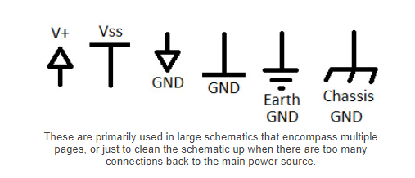

# Fundamental

# Journal 2025

## 6/Jan/25: No_OS_LIB: ADC4130 Library

### Using no_os_library kit with ADC library collection.

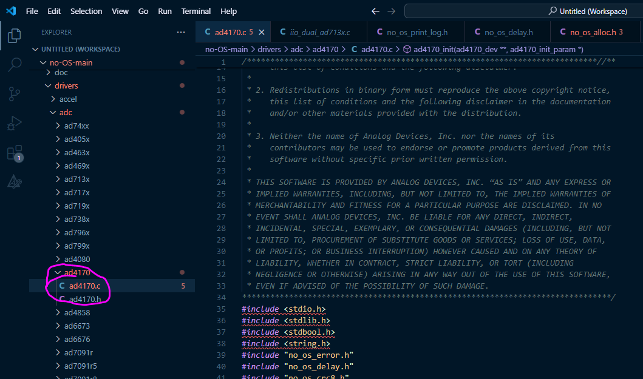 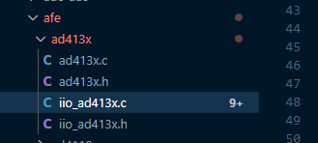

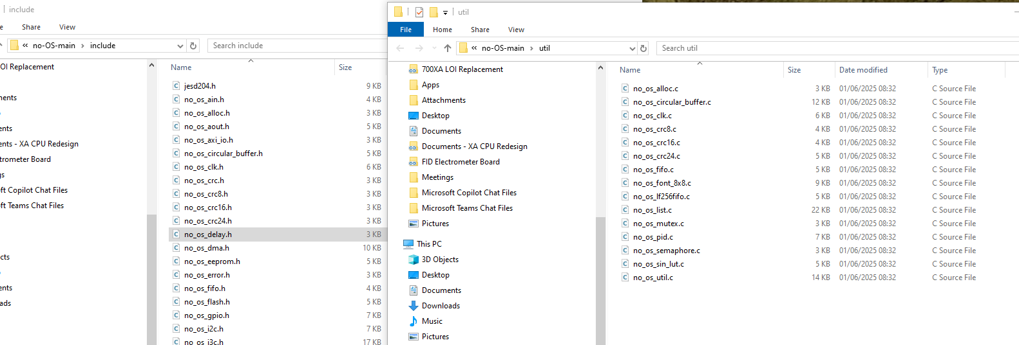

### What is _SYS_ERRNO_

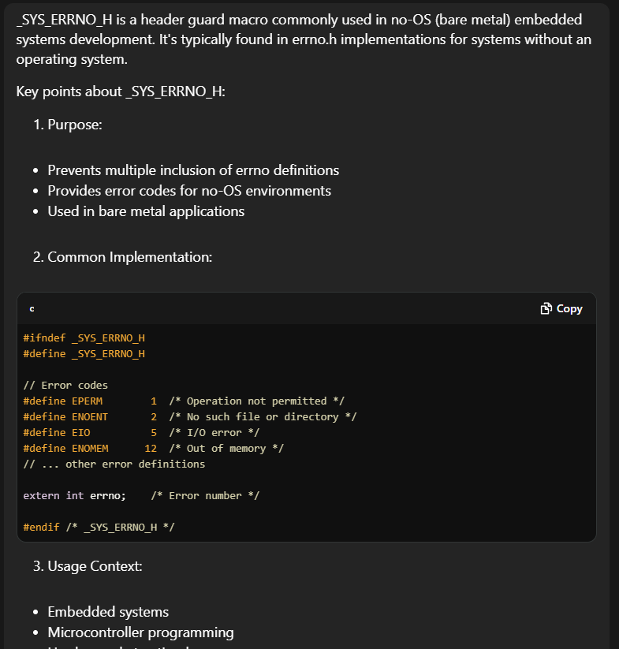 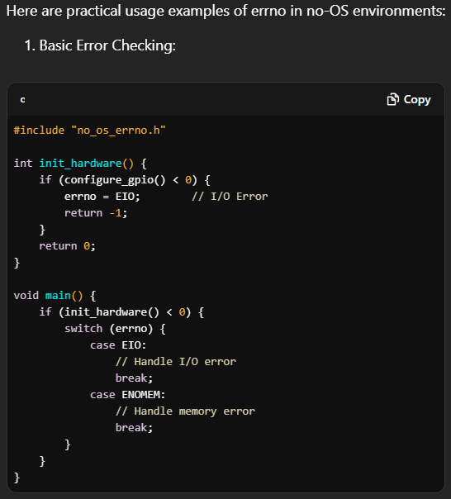 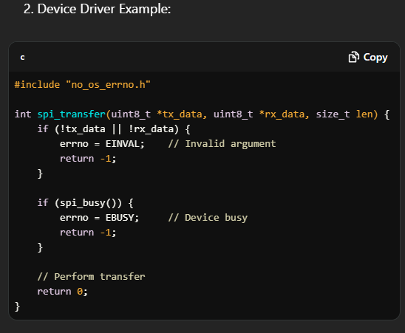

# Journal 2022

## 24/June/22: RTC Works

### Useful links

<https://kknews.cc/news/kprknyp.html>

### Successfully tested Get Time from UDT1970 variable and STM32 RTC variable and vice versa

**char** datetimestr[110];

uint32_t UDT1970RTC = STM32_RTC_ToEpoch(&rtcTime,&rtcDate);

STM32_RTC_FromEpoch(UDT1970RTC,&rtcTime2,&rtcDate2);

STM32_RTC_GetDataTimeStrA(datetimestr,80,rtcTime,rtcDate);

zprintf("RTC Method A : %s\n", datetimestr);

STM32_RTC_GetDataTimeStrB(datetimestr);

zprintf("RTC Method B : %s\n", datetimestr);

STM32_RTC_GetDataTimeStrA(datetimestr,80,rtcTime2,rtcDate2);

zprintf("UDT1970-RTC : 0x%4x\n", UDT1970RTC);

zprintf("UDT1970-RTC : %s\n", datetimestr);

STM32_UDT1970_GetDateTimeStr(datetimestr,80,zstobj->RTC_Time);

zprintf("UDT1970-SYS : 0x%4x\n", zstobj->RTC_Time);

zprintf("UDT1970-SYS : %s\n", datetimestr);

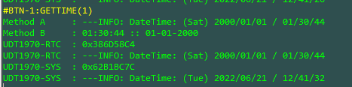

### Systick

* Override weak callback and include code to support SIR sequencer based on UDT1970 in Systick.
* Included heartbeat LED.
* Systick event every 1mSec.

### RTC works

* MX code generator does invoke code to run. It is ticking, no additional code needed.
* Testing code to support UDT1970 use via RTC XTAL

### There two formal RTC FORMAT BIN versa RTC_FORMAT_BDC

* No details found yet of what are they, it now clear it not HW implemented. It done by the code below (see HAL_RTC_GetTime())
* With < RTC FORMAT BIN>, BDC = 12 get converted to 0x0C that how it work.

/* Check the input parameters format */

**if** (Format == RTC_FORMAT_BIN)

{

/* Convert the time structure parameters to Binary format */

sTime->Hours = (uint8_t)RTC_Bcd2ToByte(sTime->Hours);

sTime->Minutes = (uint8_t)RTC_Bcd2ToByte(sTime->Minutes);

sTime->Seconds = (uint8_t)RTC_Bcd2ToByte(sTime->Seconds);

}

And

/**

* @brief Convert a 2 digit decimal to BCD format.

* @param Value Byte to be converted

* @retval Converted byte

*/

uint8_t RTC_ByteToBcd2(uint8_t Value)

{

uint32_t bcdhigh = 0U;

uint8_t temp = Value;

**while** (temp >= 10U)

{

bcdhigh++;

temp -= 10U;

}

**return** ((uint8_t)(bcdhigh << 4U) | temp);

}

/**

* @brief Convert from 2 digit BCD to Binary.

* @param Value BCD value to be converted

* @retval Converted word

*/

uint8_t RTC_Bcd2ToByte(uint8_t Value)

{

uint8_t tmp;

tmp = ((Value & 0xF0U) >> 4U) * 10U;

**return** (tmp + (Value & 0x0FU));

}

## 23/June/22: GPIO Set or Clear: HAL Method

* HAL_GPIO_WritePin(GPIOA, GPIO_PIN_1|GPIO_PIN_2|GPIO_PIN_3, GPIO_PIN_SET);
* HAL_GPIO_WritePin(GPIOA, GPIO_PIN_4|GPIO_PIN_5|GPIO_PIN_6, GPIO_PIN_RESET);

Or more directly, faster

**switch** (zstobj->ActivityLoop)

{

**case**(130):

{ // See HAL_GPIO_WritePin

GPIOA->BSRR = (uint32_t)GPIO_PIN_5; // Set

**break**;

}

**case**(30):

{

GPIOA->BRR = (uint32_t)GPIO_PIN_5; // Reset/Clear

**break**;

}

**default**:

**break**;

}

## 23/June/22: Systick review & HAL_Delay()

### Conclusion

1. The Systick is setup by HAL code which run 1mSec event.
2. It updates the global variable
3. Successfully run Heartbeat using HAL library where it run 1mSec tick event every 1mSec with heartbeat LED.
4. No more blocking delay.
5. Include UDT1970 which get ticked every 1 second, but that run on 12MHz XTAL, not 32K RTC, which is next task.

### Successfully Run HeartBeat LED via Systick 1mSec event

//========================================================================

// Purpose: Override HAL based interrupt weak HAL_IncTick()

// Input:-

// Output:-

// Note:- 1mSec run the below code, used for time dependent sequencer.

//========================================================================

**void** HAL_IncTick(**void**)

{

//-----------------------------------------

zSYSTICK_Obj *zstobj = (zSYSTICK_Obj *)zSystickHandle;

//-----------------------------------------

uwTick += (uint32_t)uwTickFreq; // HAL variable must be updated to support HAL_Delay()

//-----------------------------------------

zstobj->SysTickLoop--; // reset every 1 Sec.

zstobj->SySTickCounter++; // Constant counter 1mSec

zstobj->zSysTick.zSystickEventNow=1; // Pass to SIR loop.

**if** (zstobj->SysTickLoop==0)

{

zstobj->SysTickLoop=1000;

zstobj->SySTickCounterSec++;

zstobj->zSysTick.zSystick_500mSec_Flag=1;

zstobj->zSysTick.zSystick_1Sec_Flag=1;

zstobj->RTC_Time++;

}

### HAL_Delay() depends on Systick

* HAL_Delay() depend on Systick.
* It is blocking delay.
* It does not modify the number in the Systick, but it does not factored if number goes to 0 or

__IO uint32_t uwTick;

uint32_t uwTickPrio = (1UL << __NVIC_PRIO_BITS); /* Invalid priority */

HAL_TickFreqTypeDef uwTickFreq = HAL_TICK_FREQ_DEFAULT; /* 1KHz */

Most of the time the function which increments the HAL tick counter is hooked to SysTick interrupt, which is configured to tick every 1ms. Therefore HAL_GetTick() will return the number of milliseconds since the SysTick interrupt is configured (essentially since the program start). This can also be though of as "the number of times the SysTick interrupt has 'ticked'".

/* Use SysTick as time base source and configure 1ms tick (default clock after Reset is MSI) */

**if** (HAL_InitTick(TICK_INT_PRIORITY) != HAL_OK)

{

status = HAL_ERROR;

}

**else**

{

/* Init the low level hardware */

HAL_MspInit();

}

Then it goes to below

/**

* @brief This function configures the source of the time base:

* The time source is configured to have 1ms time base with a dedicated

* Tick interrupt priority.

* @note This function is called automatically at the beginning of program after

* reset by HAL_Init() or at any time when clock is reconfigured by HAL_RCC_ClockConfig().

* @note In the default implementation, SysTick timer is the source of time base.

* It is used to generate interrupts at regular time intervals.

* Care must be taken if HAL_Delay() is called from a peripheral ISR process,

* The SysTick interrupt must have higher priority (numerically lower)

* than the peripheral interrupt. Otherwise the caller ISR process will be blocked.

* The function is declared as __weak to be overwritten in case of other

* implementation in user file.

* @param TickPriority Tick interrupt priority.

* @retval HAL status

*/

__weak HAL_StatusTypeDef HAL_InitTick(uint32_t TickPriority)

{

HAL_StatusTypeDef status = HAL_OK;

/* Check uwTickFreq for MisraC 2012 (even if uwTickFreq is a enum type that doesn't take the value zero)*/

**if** ((uint32_t)uwTickFreq != 0U)

{

/*Configure the SysTick to have interrupt in 1ms time basis*/

**if** (HAL_SYSTICK_Config(SystemCoreClock / (1000U / (uint32_t)uwTickFreq)) == 0U)

{

/* Configure the SysTick IRQ priority */

**if** (TickPriority < (1UL << __NVIC_PRIO_BITS))

{

HAL_NVIC_SetPriority(SysTick_IRQn, TickPriority, 0U);

uwTickPrio = TickPriority;

}

**else**

{

status = HAL_ERROR;

}

}

**else**

{

status = HAL_ERROR;

}

}

**else**

{

status = HAL_ERROR;

}

/* Return function status */

**return** status;

}

The interrupt goes to here

**void** SysTick_Handler(**void**)

{

/* USER CODE BEGIN SysTick_IRQn 0 */

/* USER CODE END SysTick_IRQn 0 */

HAL_IncTick();

/* USER CODE BEGIN SysTick_IRQn 1 */

/* USER CODE END SysTick_IRQn 1 */

}

Which is weak function so I can create my interrupt routine every 1mSec which is perfect!!

/**

* @brief This function is called to increment a global variable "uwTick"

* used as application time base.

* @note In the default implementation, this variable is incremented each 1ms

* in SysTick ISR.

* @note This function is declared as __weak to be overwritten in case of other

* implementations in user file.

* @retval None

*/

__weak **void** HAL_IncTick(**void**)

{

uwTick += (uint32_t)uwTickFreq;

}

## 18/June/22: Setting up Timer

* Below is the complete IOC setup for TMR16

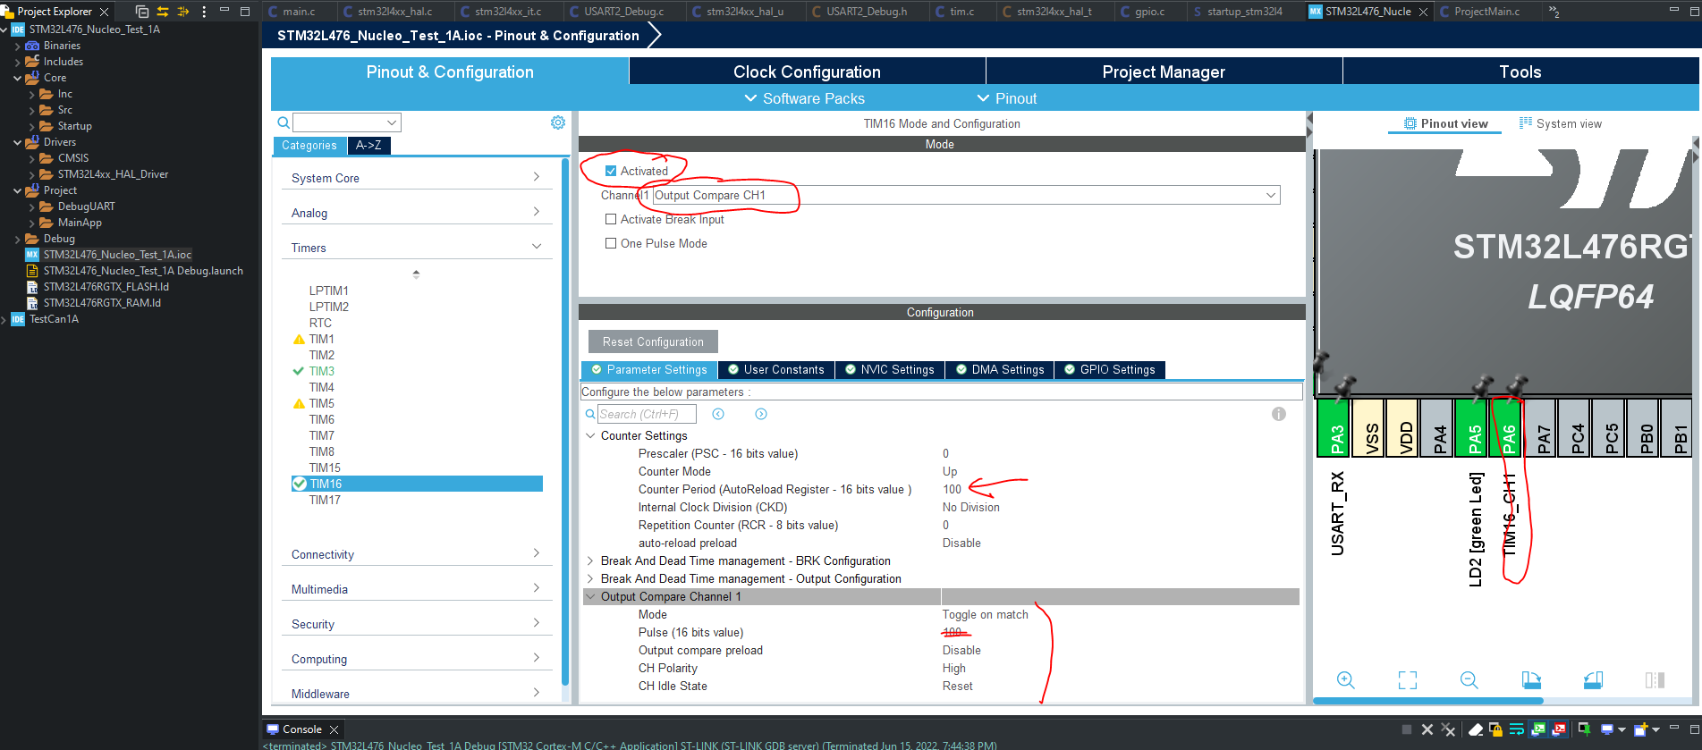

* However it did not run because the go command need to be manually inserted as shown below.

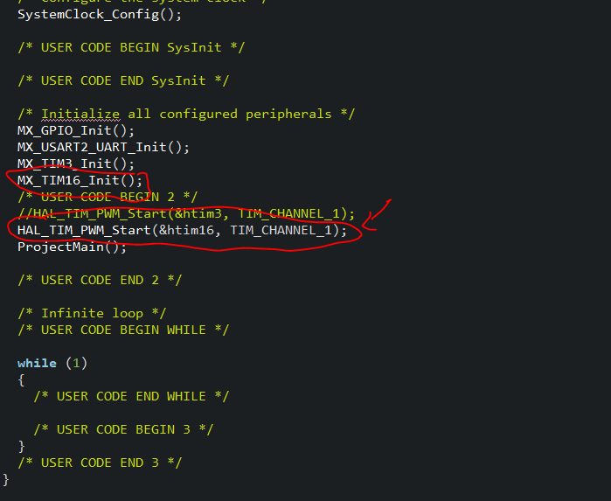

And it provides 400KH. The core clock is 80MHz / 100 = 800,000Hz toggle => 400KHz.

# Installation

## General

STM32CubeIDE is an all-in-one multi-OS development tool, which is part of the STM32Cube software ecosystem.

STM32CubeIDE is an advanced C/C++ development platform with peripheral configuration, code generation, code compilation,

and debug features for STM32 microcontrollers and microprocessors. It is based on the Eclipse®/CDT™ framework and GCC

toolchain for the development, and GDB for the debugging. It allows the integration of the hundreds of existing plugins that

complete the features of the Eclipse® IDE.

STM32CubeIDE integrates STM32 configuration and project creation functionalities from STM32CubeMX to offer all-in-one tool

experience and save installation and development time. After the selection of an empty STM32 MCU or MPU, or preconfigured

microcontroller or microprocessor from the selection of a board or the selection of an example, the project is created and

initialization code generated. At any time during the development, the user can return to the initialization and configuration of the

peripherals or middleware and regenerate the initialization code with no impact on the user code.

STM32CubeIDE includes build and stack analyzers that provide the user with useful information about project status and

memory requirements.

STM32CubeIDE also includes standard and advanced debugging features including views of CPU core registers, memories,

and peripheral registers, as well as live variable watch, Serial Wire Viewer interface, or fault analyzer.

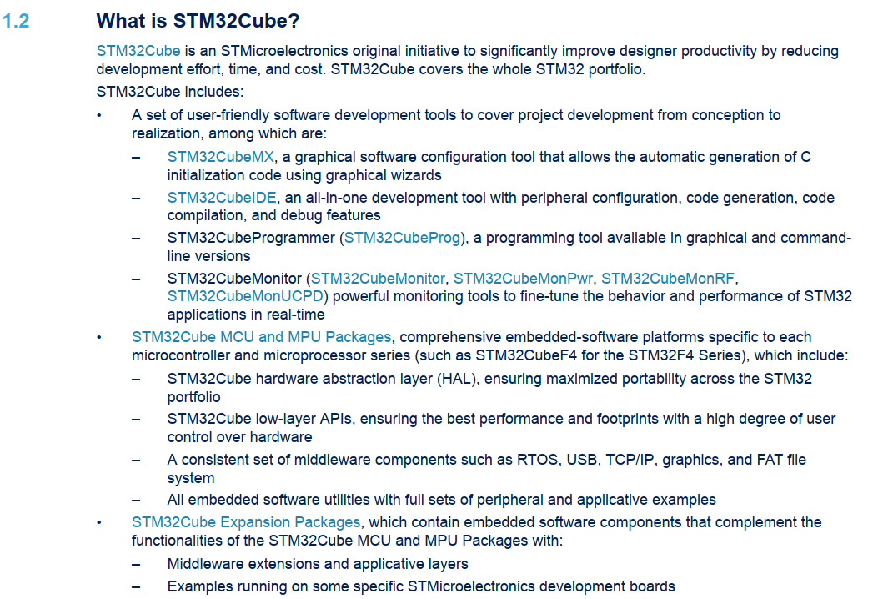

## IDE Software: STMCube IDE

<https://www.st.com/en/product/stm32cubeide?ecmp=tt9470_gl_link_feb2019&rt=db&id=DB3871>

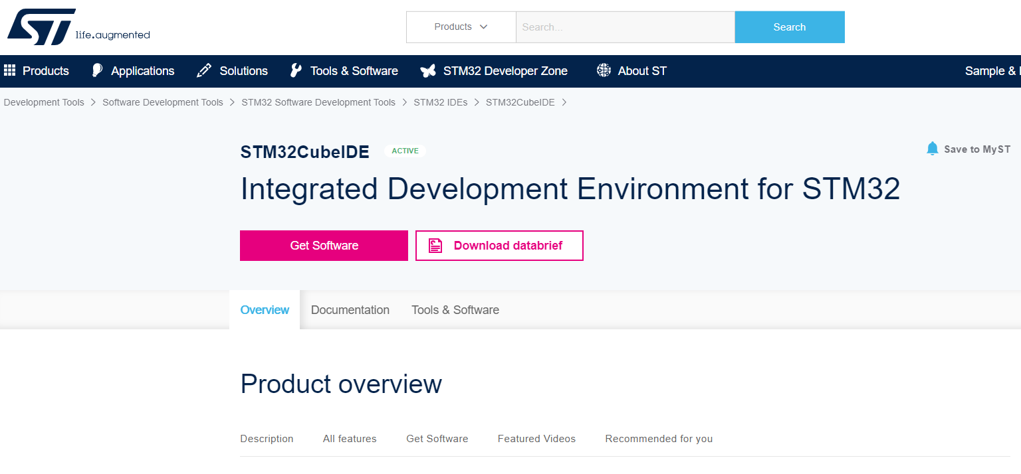

## MCU Header/Driver Package

### Install Resource

<https://www.st.com/en/embedded-software/stm32cube-mcu-mpu-packages.html>

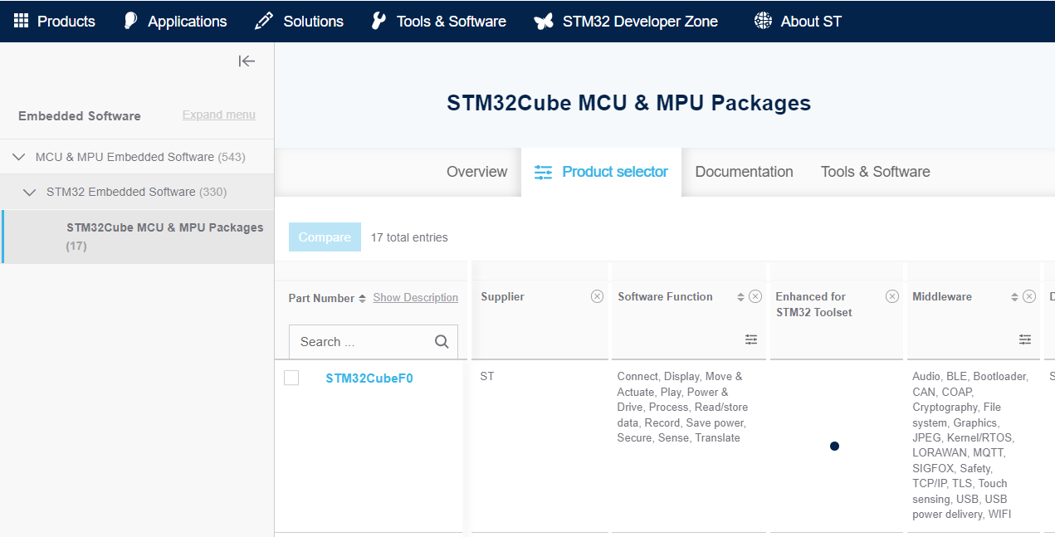

### IDE Overview

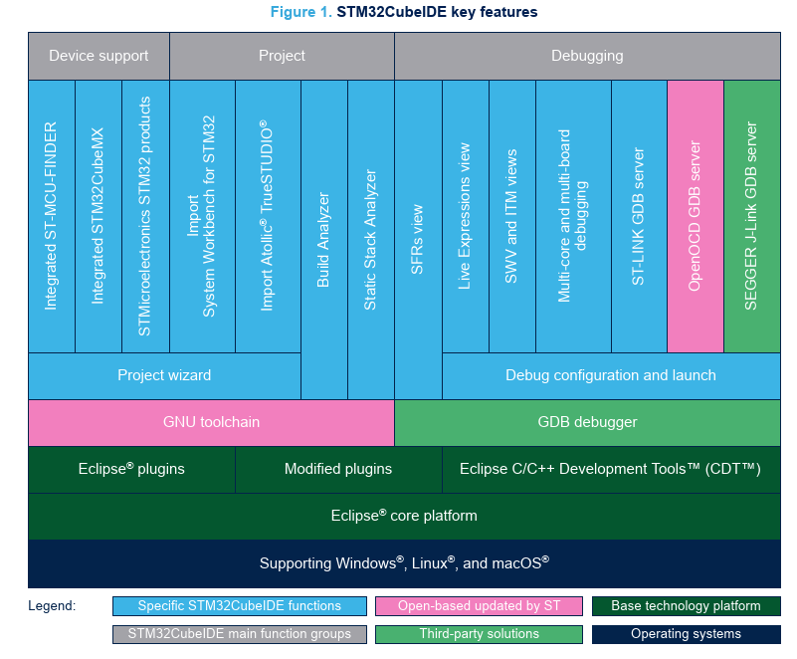

### Install extension

* Devstyle Worked fine
* Eclipse Explorer Worked fine, this is workable solution.

NB: Wait for software installation to be completed !!

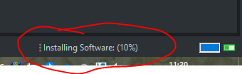

## STM32CubeMX device configuration

### Overview



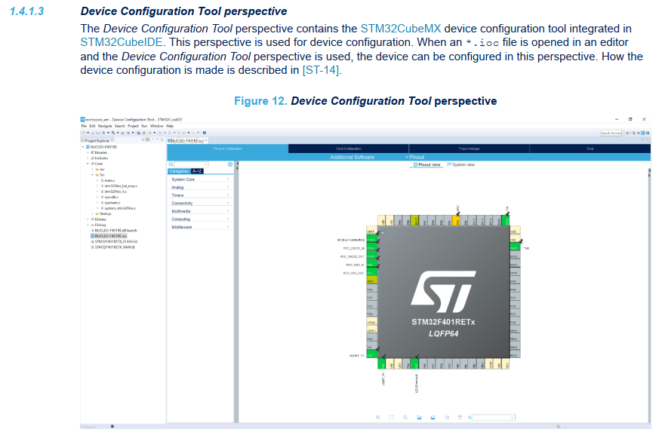

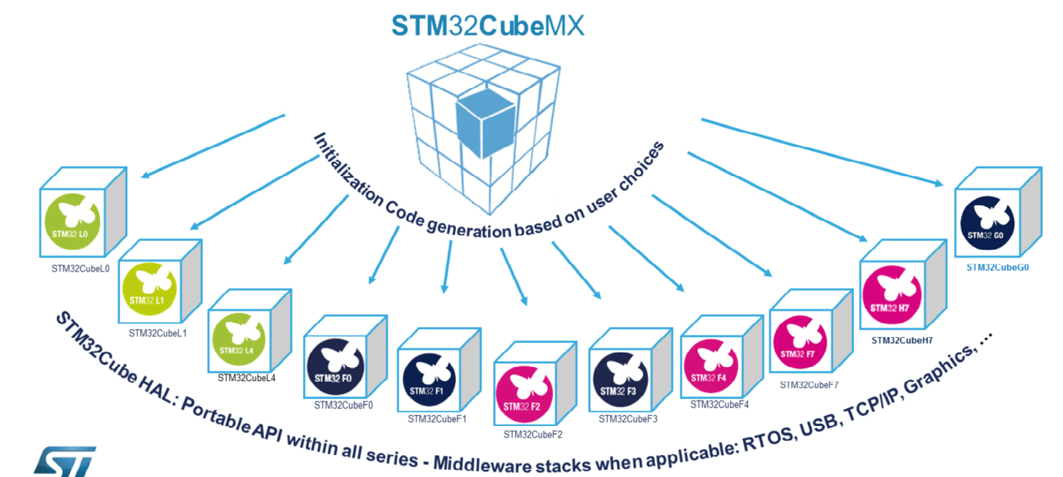

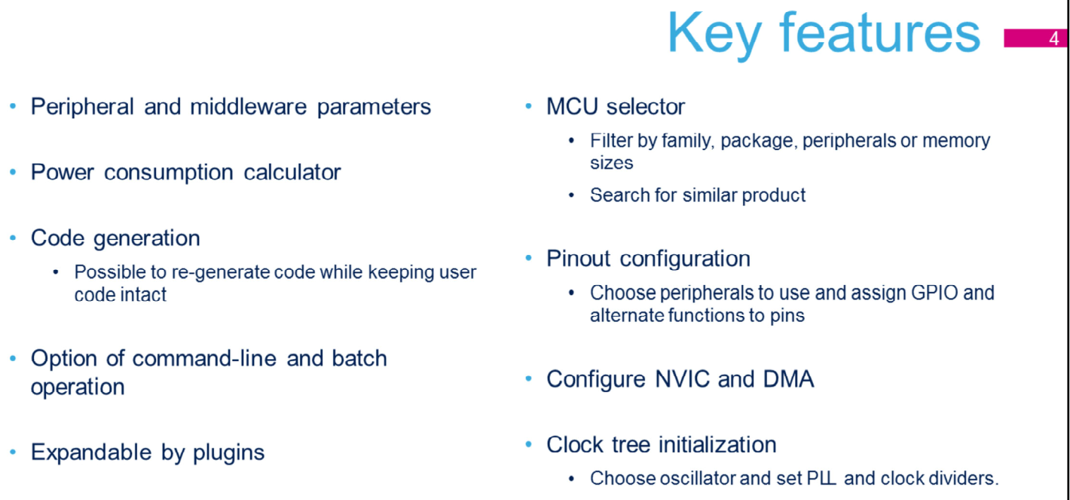

### CubeMX: STML476-Necleo: UART Setup

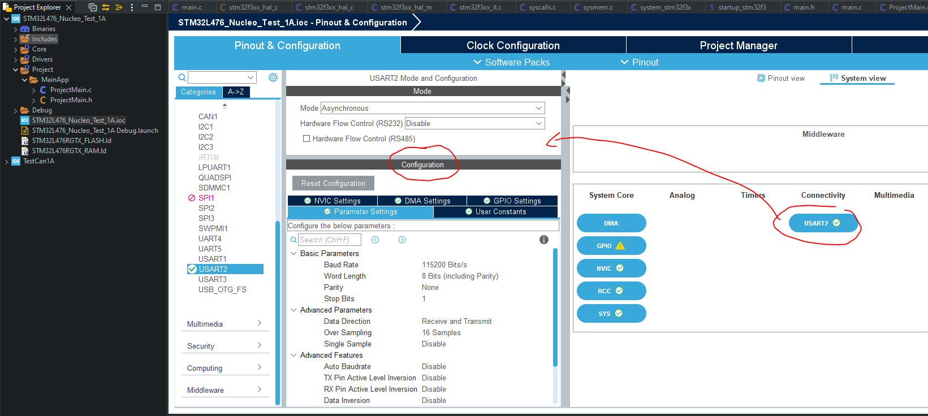

### CubeMX: Code Generation Tips: follows the comment out code to avoid losing the code!!

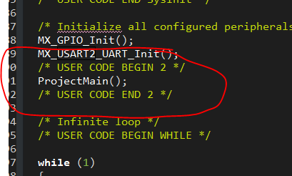

### System Clock Section

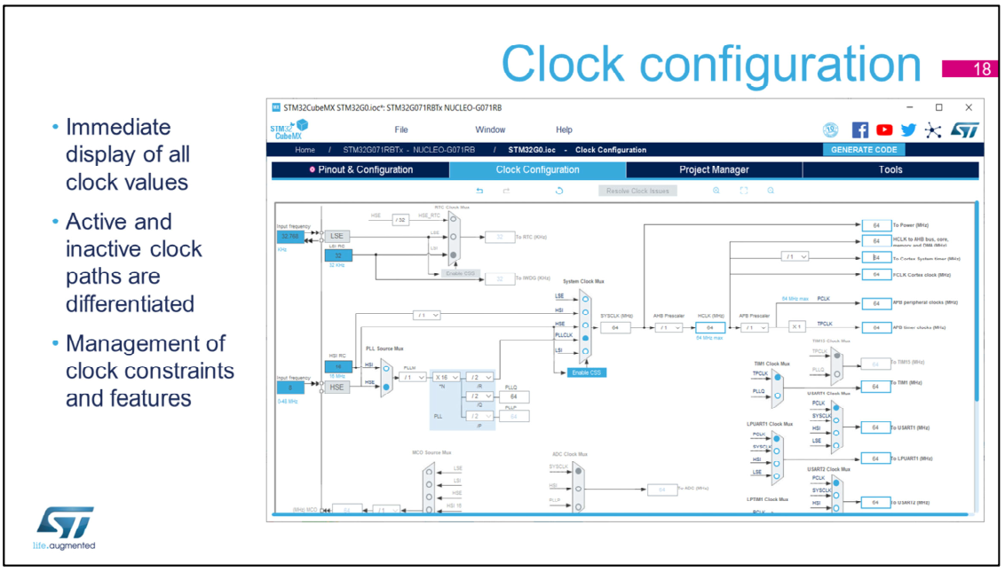

### NVIC ISR Section

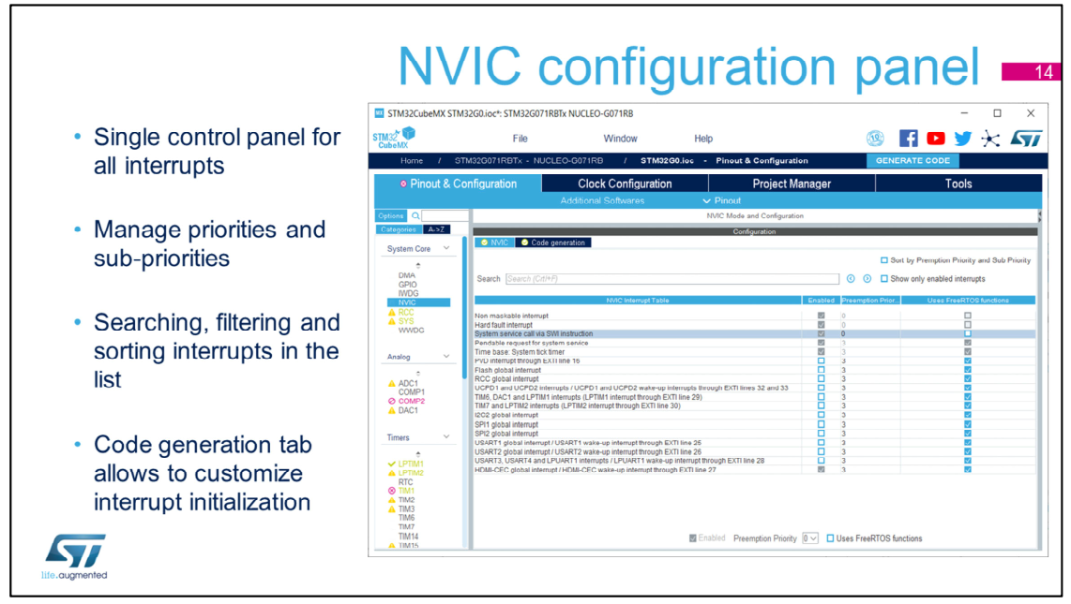

### DMA Section: It just setup DMA config and code, but need app code to finish it

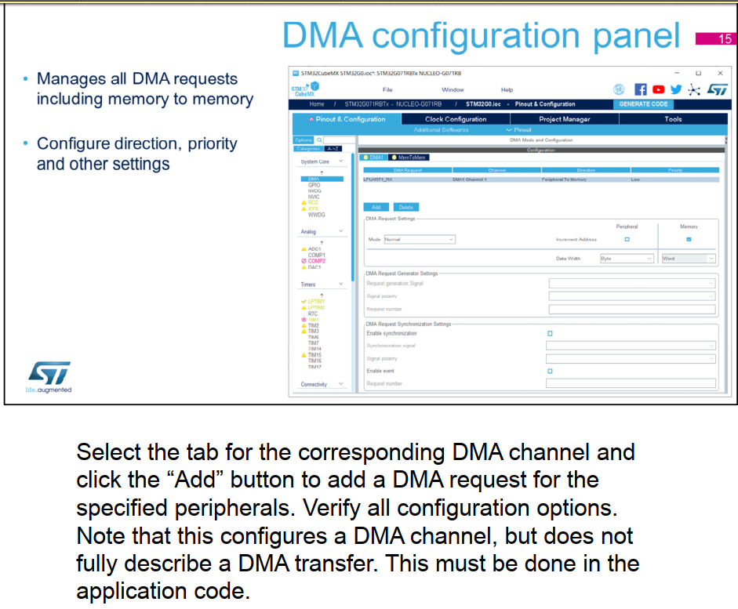

### Warning & Disclaimer

* Only work with HAL library, will not work on LL library.
* You cannot have both HAL and LL library for same perpherial, but can have both HAL and LL for different peripheral, ie speed critical SPI bus can be setup under LL while rest of the code are HAL.

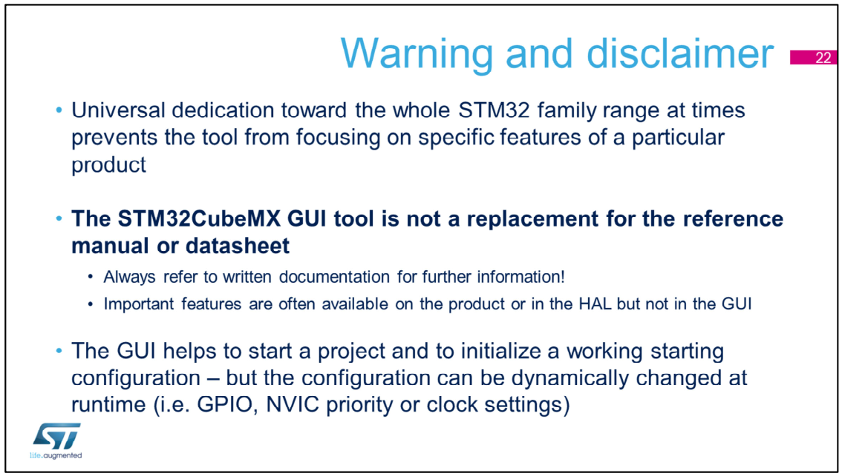

The user interface is a great tool, it is a universal assistant for all STM32 microcontrollers. However it cannot tackle all the details of each product while providing a useful overview of the diversified STM32 portfolio.

In case of doubt, please refer to the reference manual or datasheet for more detailed and accurate information. Do not hesitate to read the application notes and examples to learn more. It is common practice to start an application with STM32CubeMX to quickly get a prototype working, and then, modify the code when dynamic changes are needed (typically to support a different clock or GPIO configuration in the same application).

If the user writes the code within the user areas defined by the STM32CubeMX generator, they can return to the initial STM32CubeMX setup, if some modifications need to be applied at the top level of user interface. This typically involves adding GPIO pin configurations, changing the clock, or changing the NVIC Priority, for example.

### Project Manager: Code Generator project setting

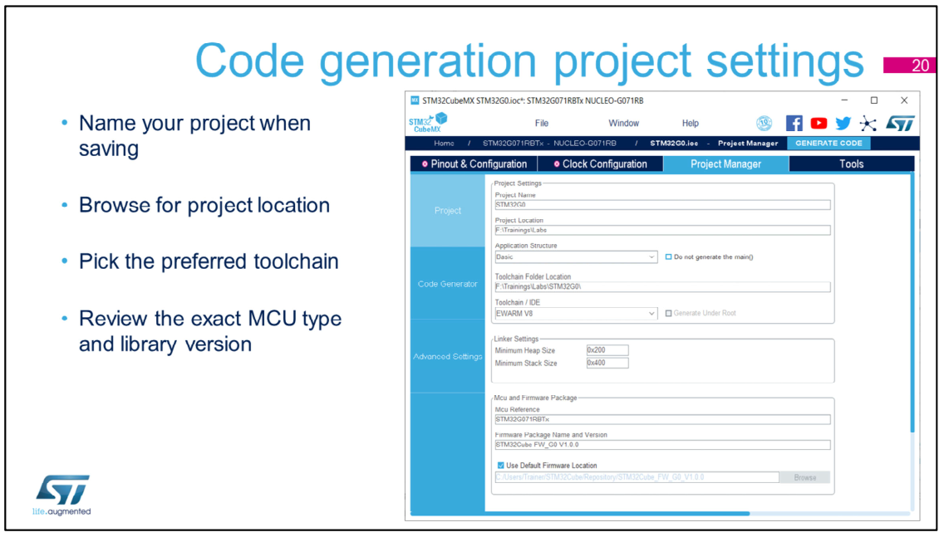

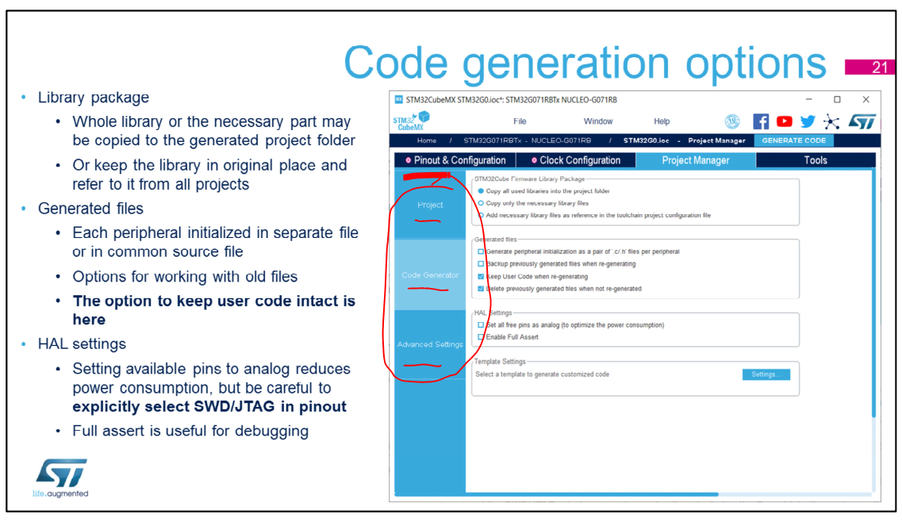

The STM32Cube HAL library may be associated with the project in various ways. Select the Copy option if the project should be migrated as a compact package or if there is a need to customize the library code. Keeping the library in the original location makes it easier to share the latest version of the library among several projects.

It can also generate the initialization code for all peripherals together in the stm32fxxx_hal_msp.c file, or generate one file per peripheral.

Options to back up or delete old files are a matter of the preferred workflow. Keep in mind that the options are tied to the re-generation function. This is also where the “keep user code when re-generating” option is enabled.

The “Set all free pins as analog” setting helps lower power consumption, but if the SWD/JTAG interface is not specifically selected in the Pinout tab, this option will disable the debug interface.

“Full assert” enables checking the parameters passed to the HAL functions, and may help reveal some bugs in the user code without an excessive debugging effort.

### Power Consumption Calculation

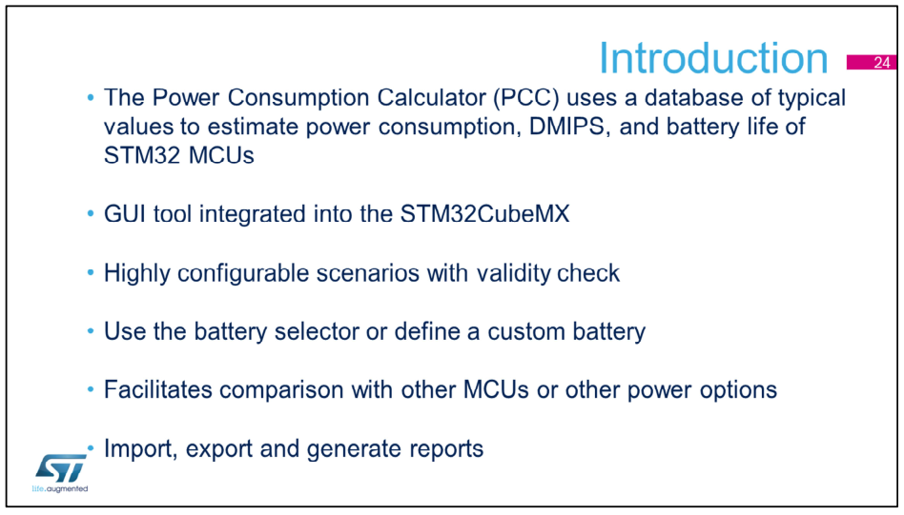

### Reference Materials

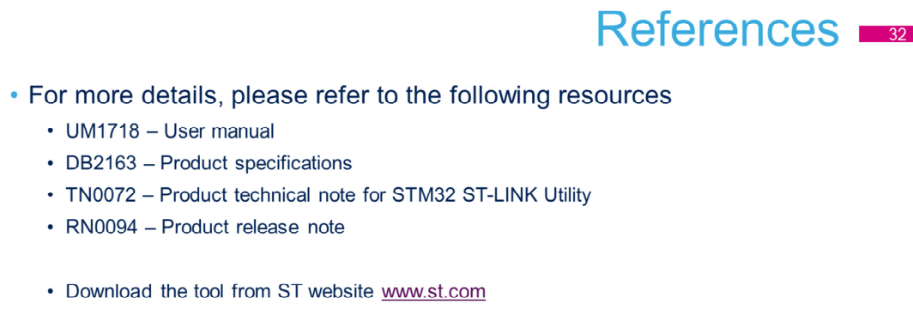

## CubeIDE EcoSystem



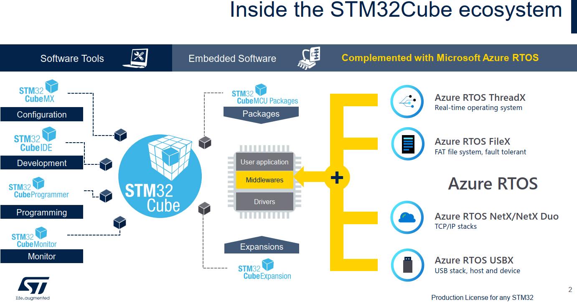

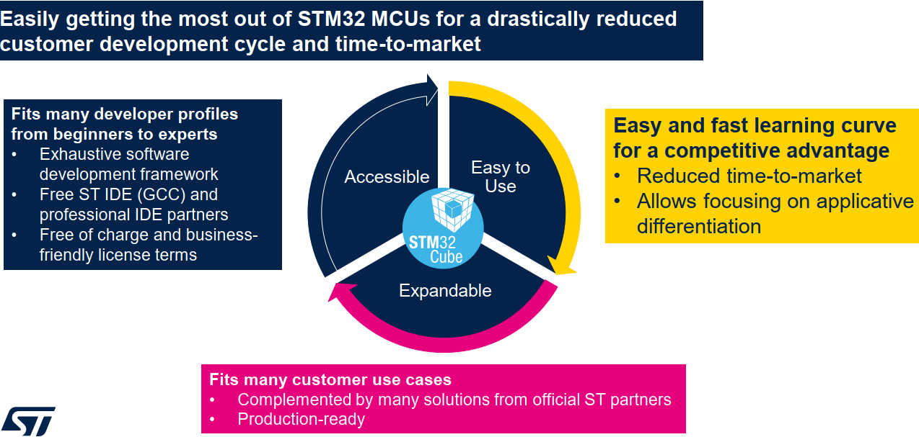

### Project Management: IOC Editor and Importer

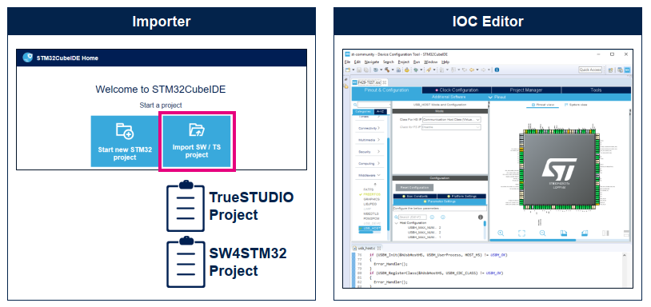

### Code Navigation

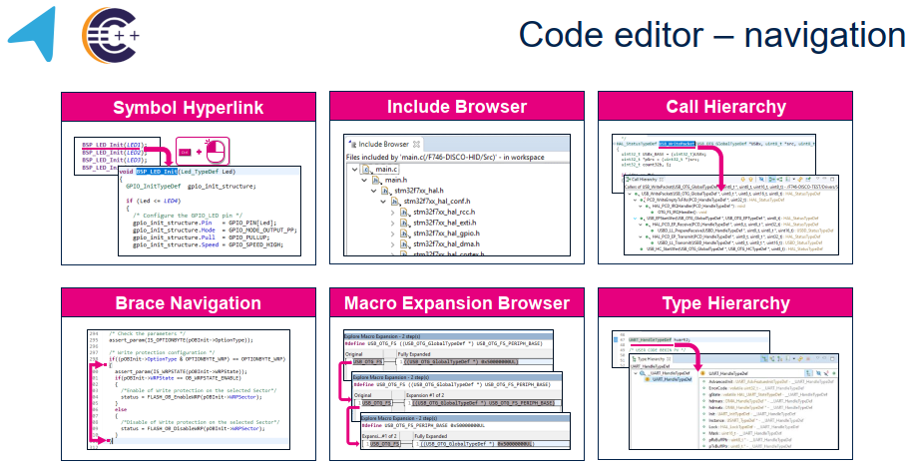

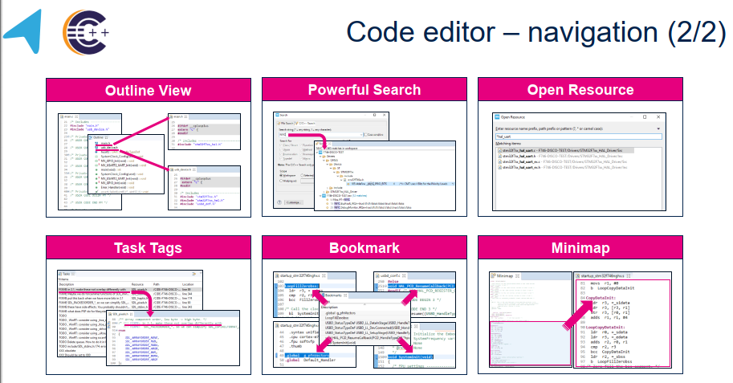

### Code Editor

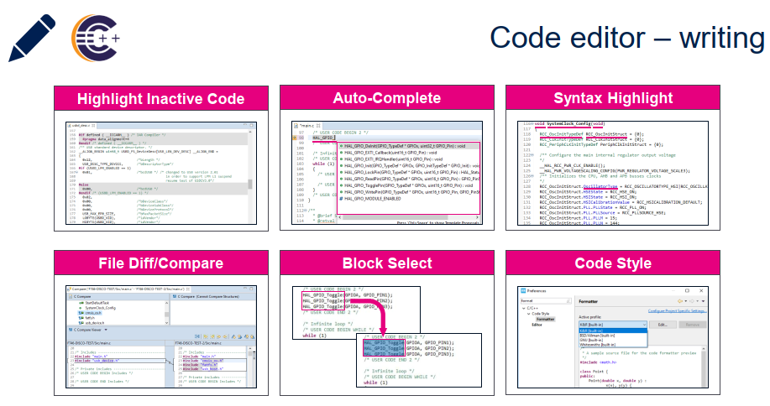

### Build Tools

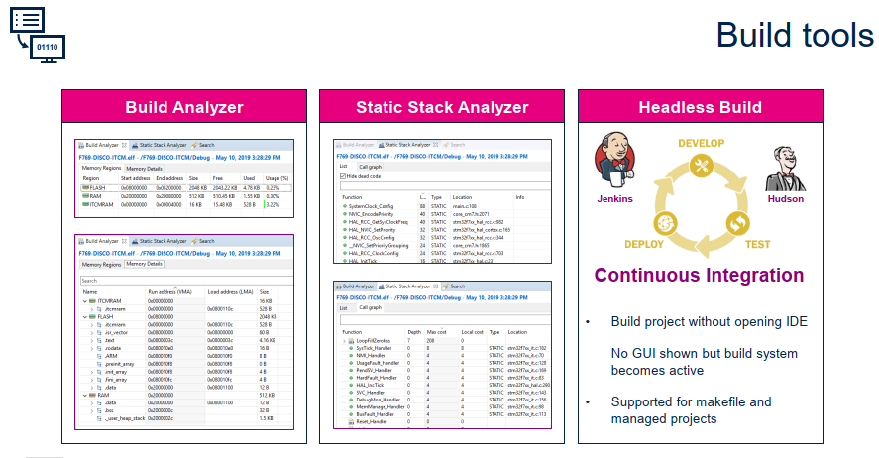

### Debug

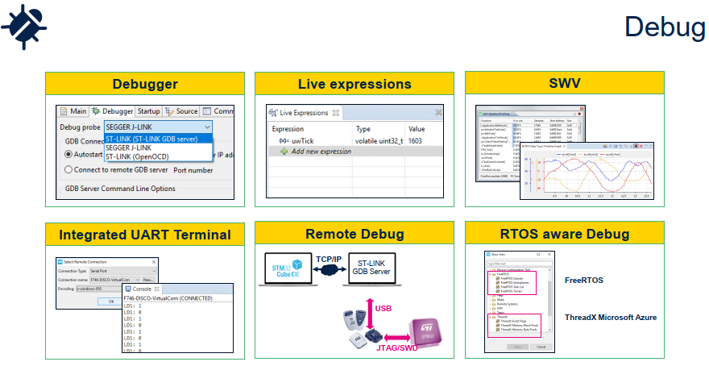

### Cube Monitor (That new!)

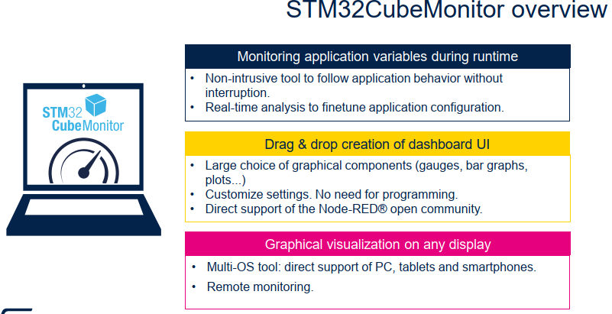 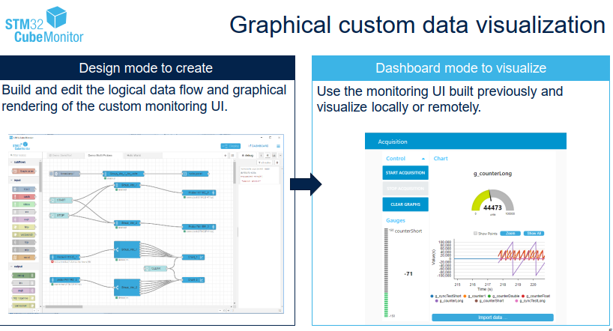

### Remote Monitoring

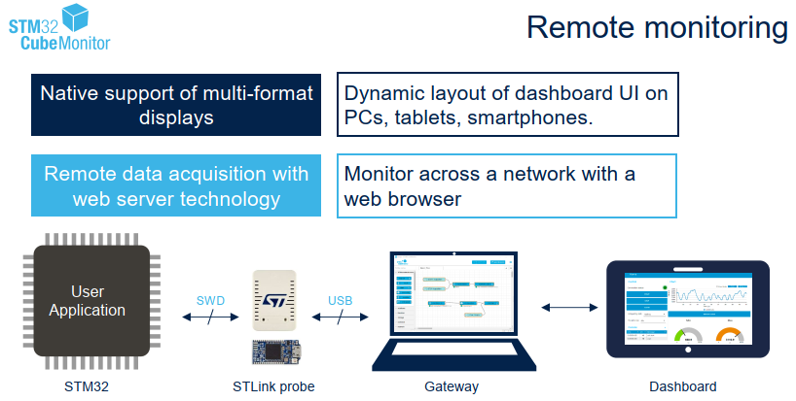

### Power

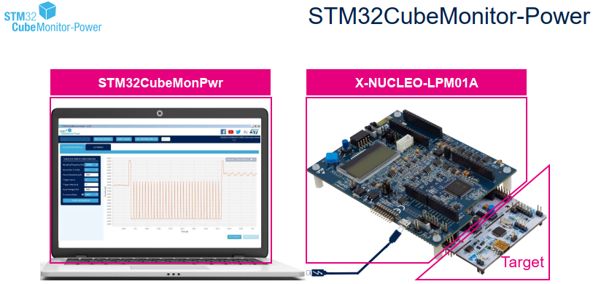

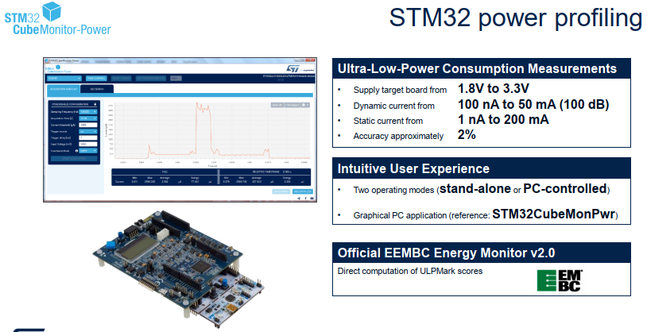

### USB Device

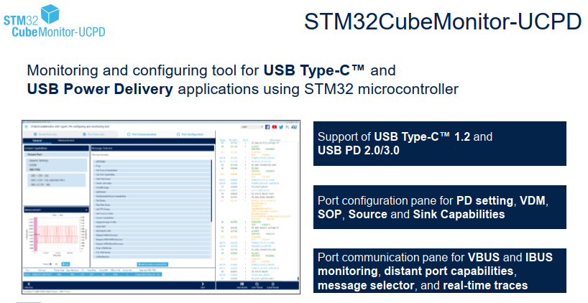

### Design Process

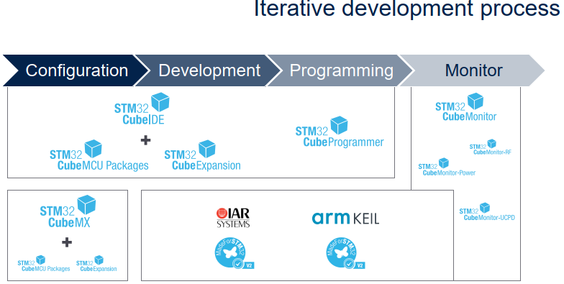

# STM32 Software & Library Concept

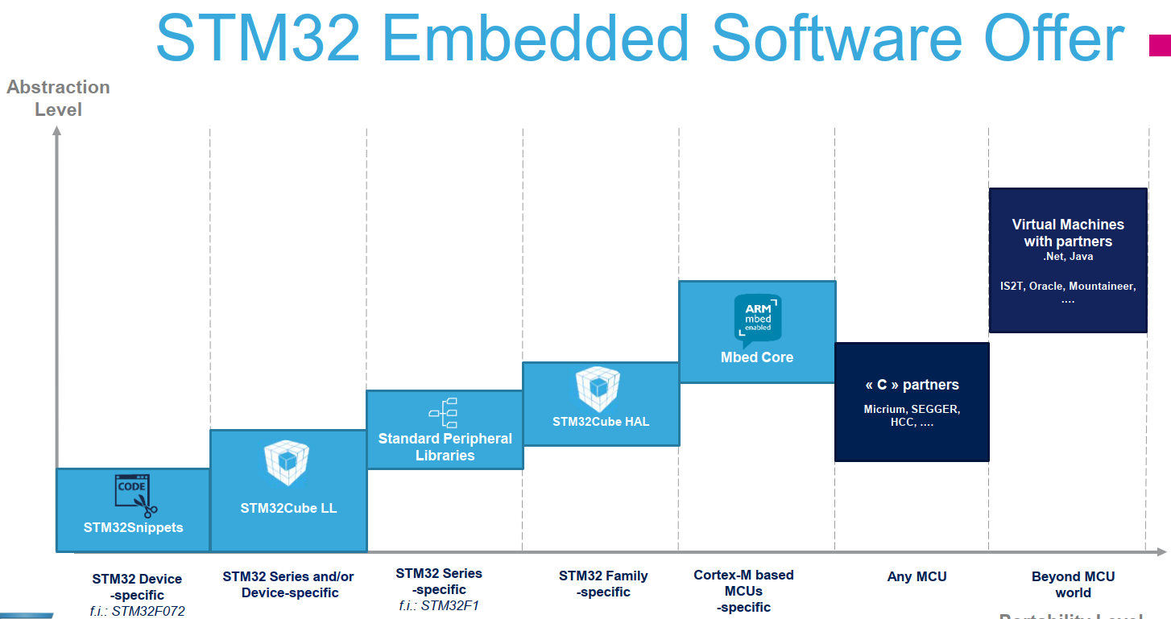

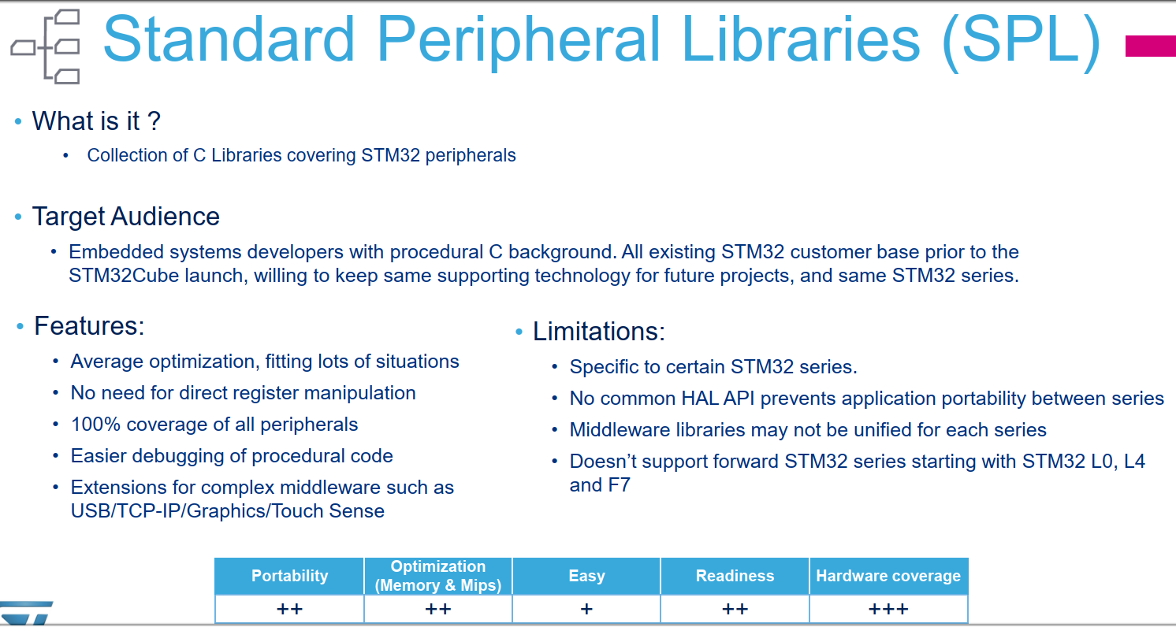

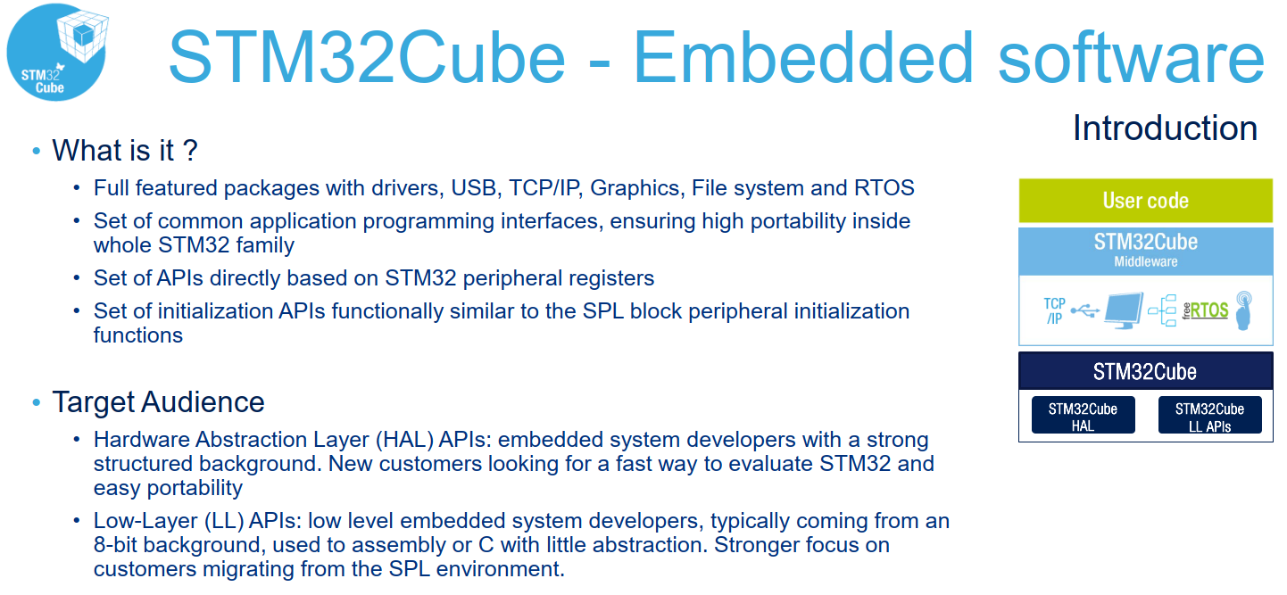

* There LL API Low level, resource critical custom code. Better for speed and memory use.
* There HAL API Slower than LL but portable between STM32 family. This is important consideration for chip shortage issue.
* **Cannot mix together at same time**……take care!
* Try use HAL much as possible and leave LL for custom dedicated application (high speed, etc)

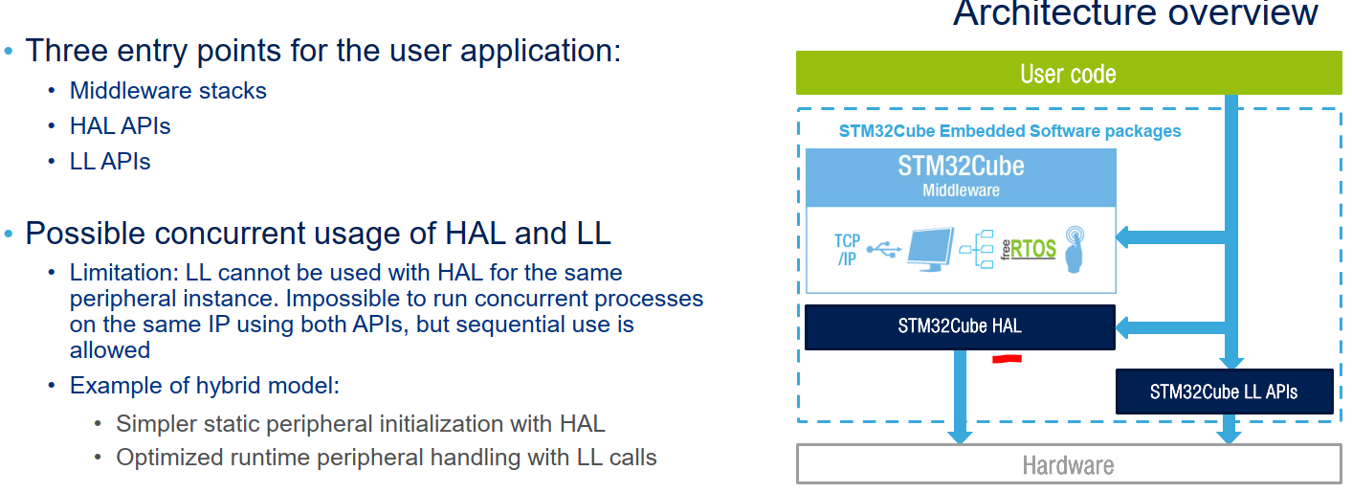

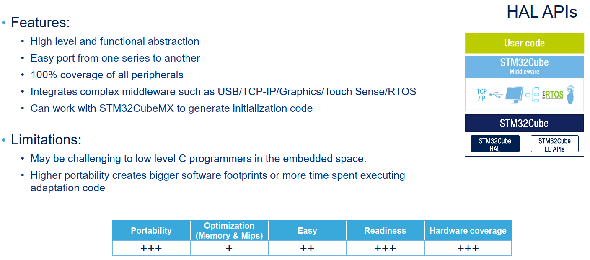

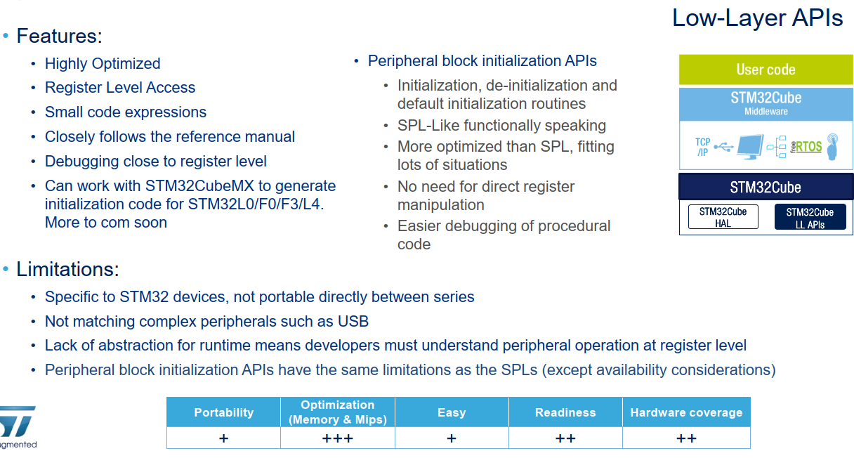

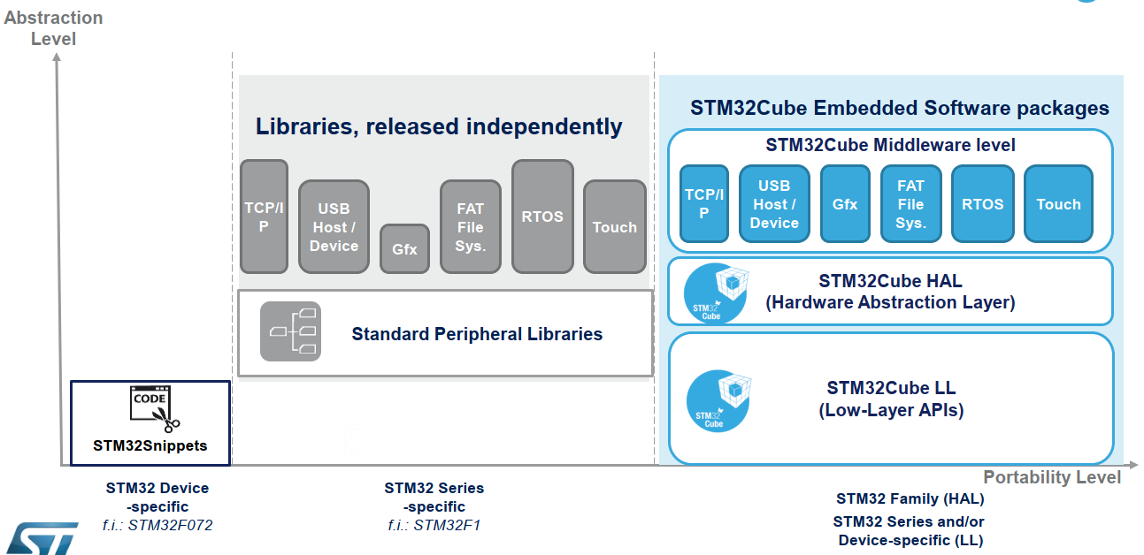

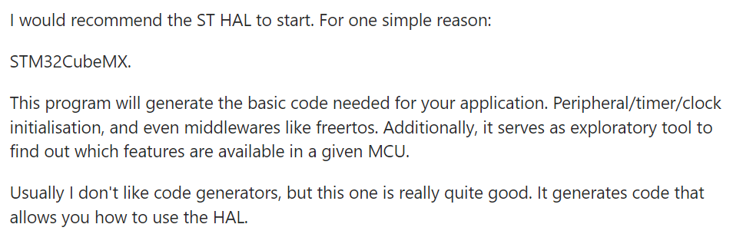

# STM32 Nucleo-64 (STM32L476RGT6)

## File Ref

E:\014_WorkSTM32\016_STM32L476_Nucleo

## Useful Resources

<http://stm32f4-discovery.net/2017/07/stm32-tutorial-efficiently-receive-uart-data-using-dma/>

<https://www.st.com/content/st_com/en/support/learning/stm32-education/stm32-online-training/stm32l4plus-online-training.html>

<https://www.st.com/en/embedded-software/stm32-embedded-software.html>

<https://www.se.rit.edu/~rweil/STM32CubeProjectsList.html> 2017 Stuff…Old.

<https://www.st.com/en/microcontrollers-microprocessors/stm32l4-plus-series.html> <<< L4 Stuff Overview, etc.

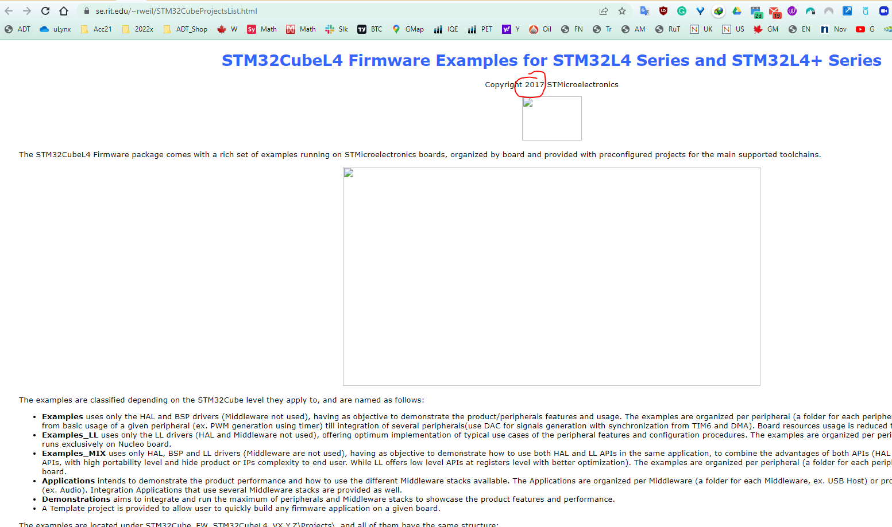

## Overview

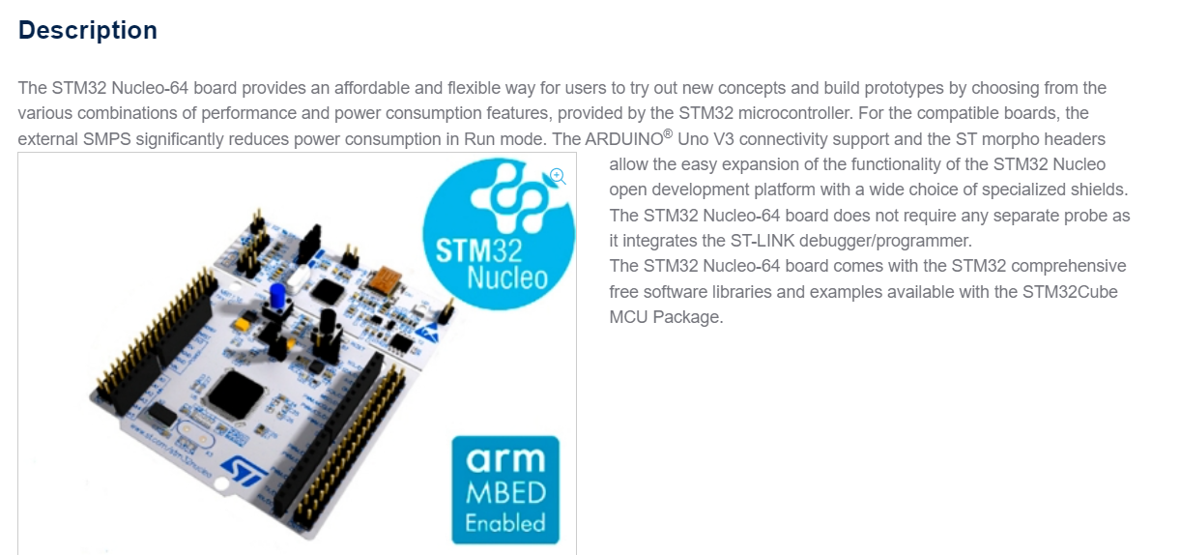

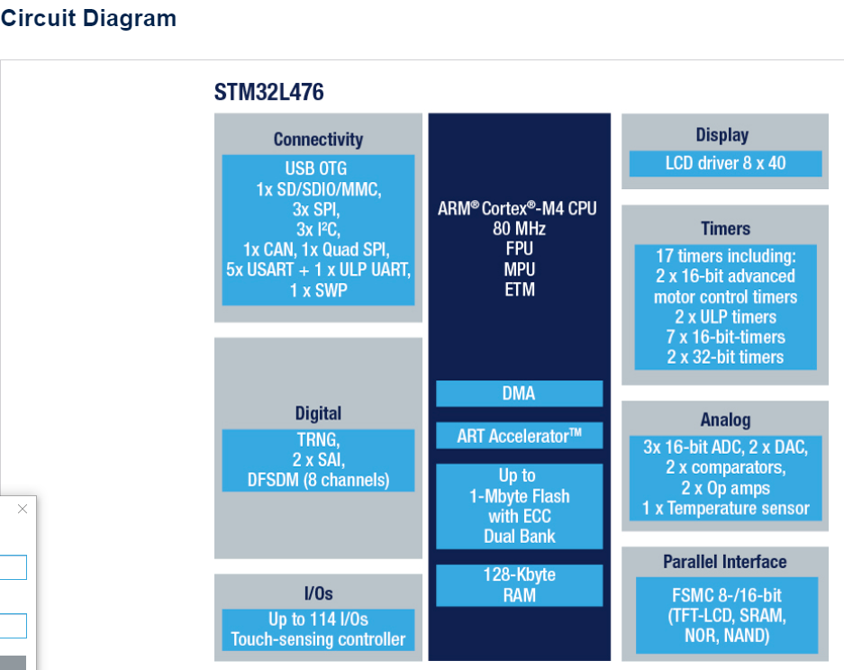

## Create new blank project

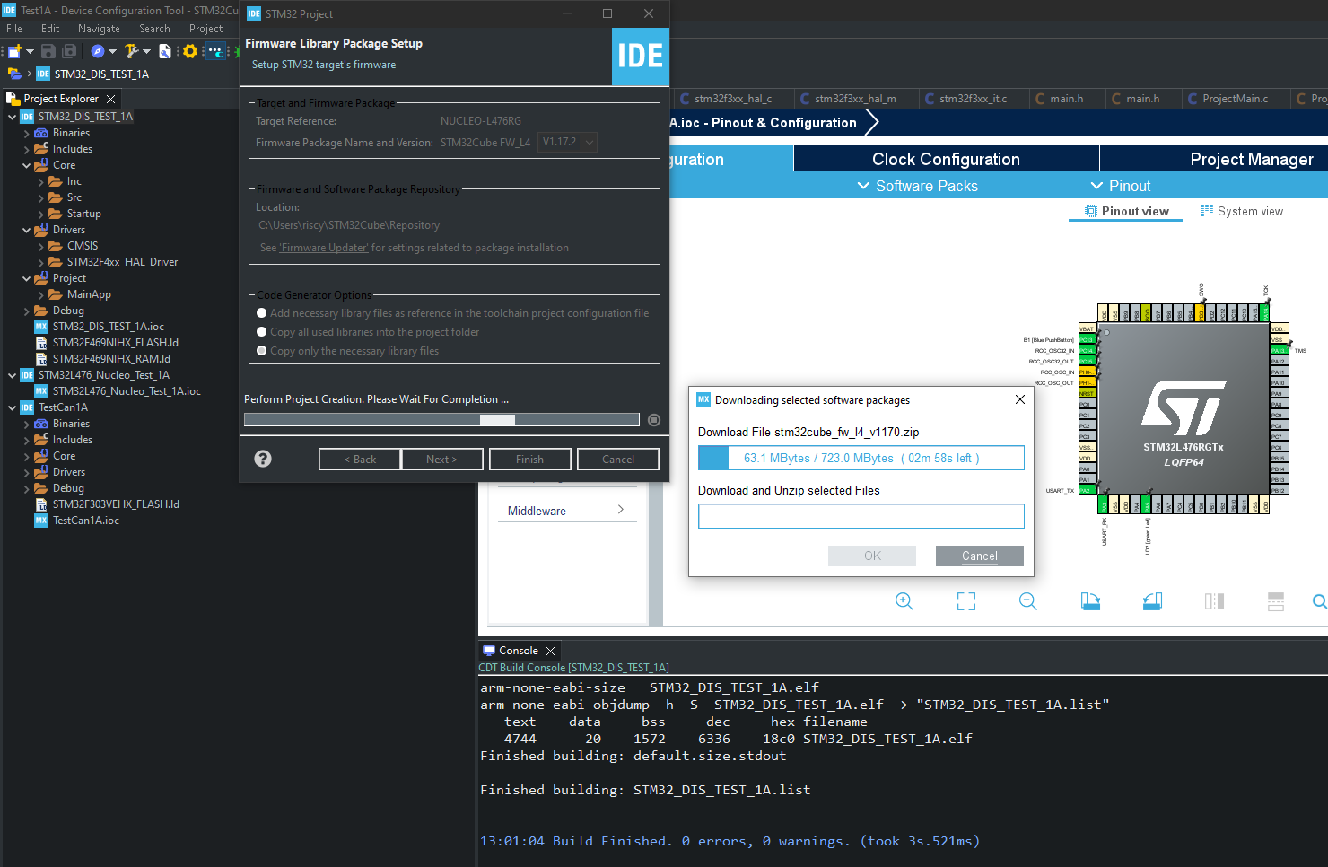

## Simple LED blinking

* LD2 = PA5

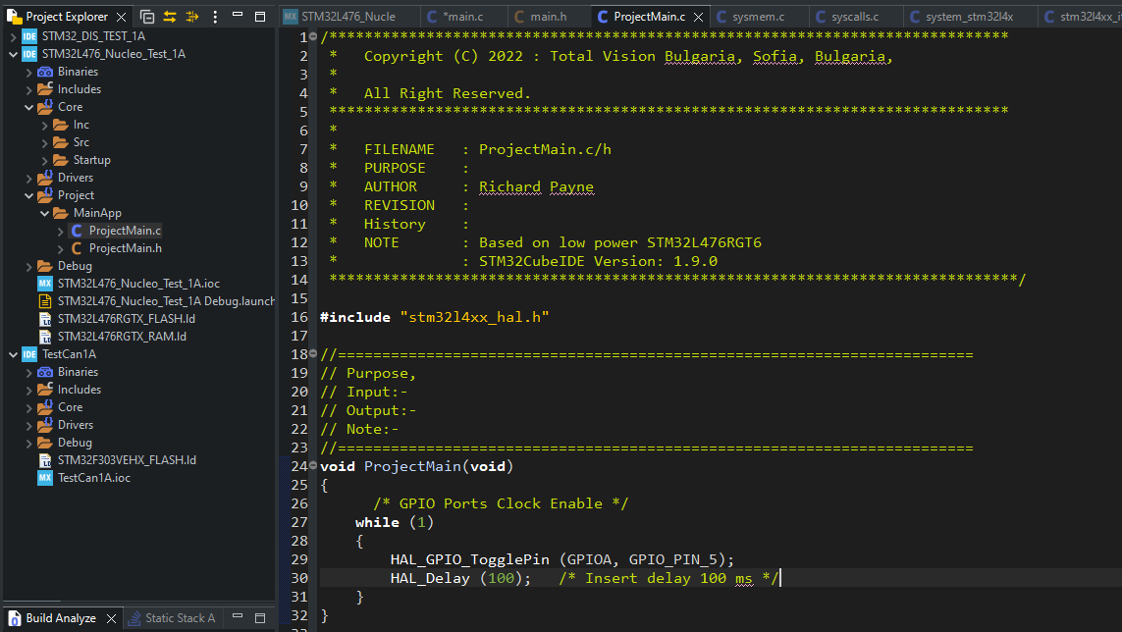

## Difference between L1 and L4 in USART

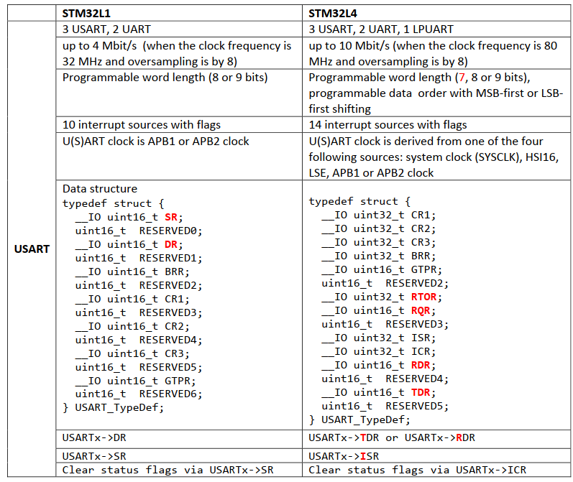

## UART Implementation: STM32CubeMX: USART2 for PA2/PA3 which tied to STLINK UART.

<https://wiki.st.com/stm32mcu/wiki/STM32StepByStep:Step3_Introduction_to_the_UART>

<https://www.youtube.com/watch?v=l5msGz2tZP0&t=29s> Good overview of Polling/Interrupt and DMA method.

### Note about the L476-EVAL Board

* UART = PA2/PA3. It need to be linked SB62/63/61 to get thro to the STLINK device

### CubeMX Implementation (config only, minimum)

1. The CubeMX implementation is useful but only minimum config code.
2. Can save time fiddle with USART register.
3. Need learning curve to use it correctly
4. Split into 3 different config: POLLING, INTERRUPTS and DMA+INTERRUPTS.
5. Also feature callback.

### Resources link to details DMA/ISR/POLLING

<https://controllerstech.com/uart-receive-in-stm32/>

<https://deepbluembedded.com/how-to-receive-uart-serial-data-with-stm32-dma-interrupt-polling/>

### Polling (avoid, blocking implementation)

1. Avoid, poor use of MCU resources.
2. The data is Received in blocking mode i.e the CPU will block every other operation until the data Reception is complete.
3. Nasty work!

But for transmits, this is reasonable solution for zprint() use because the code send out discrete byte a time just like putc(ASCII)

1. HAL_UART_Transmit() blocks until characters sent, or timeout.

### Interrupt (good solution for variable length, non-blocking)

<https://www.youtube.com/watch?v=xE6GVt7XuJI>

<https://www.youtube.com/c/Weblearning1/search?query=HAL> Very good video series.

1. Better, but do extracts resource from interrupts.
2. Limited to 1 byte transfer principle for variable length (not ideal).
3. No way to detect ‘\n’ without FW.

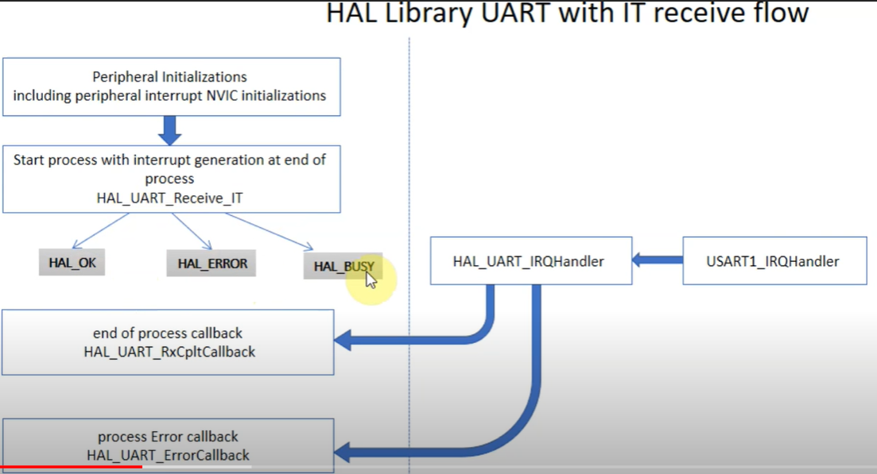

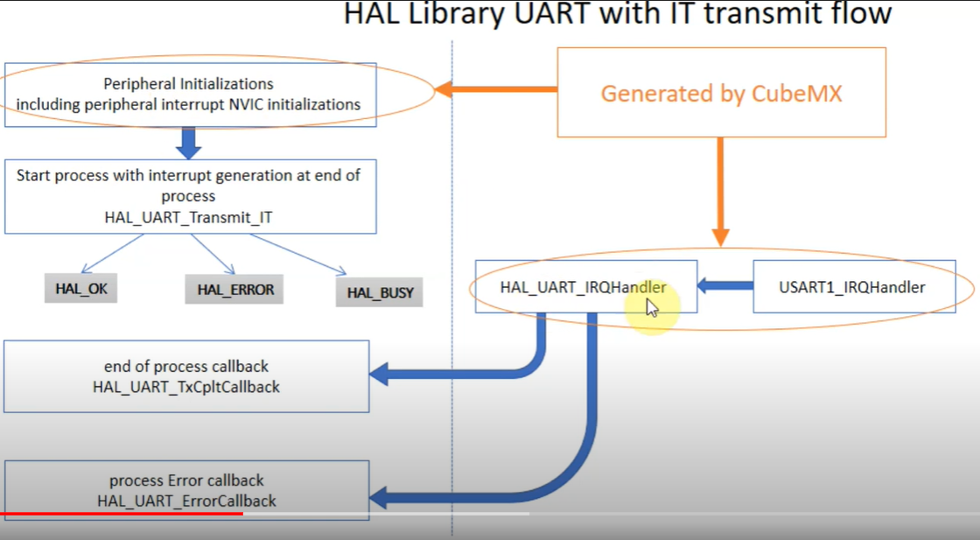

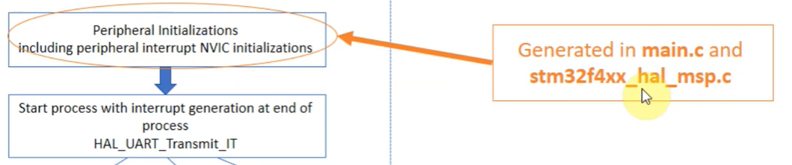

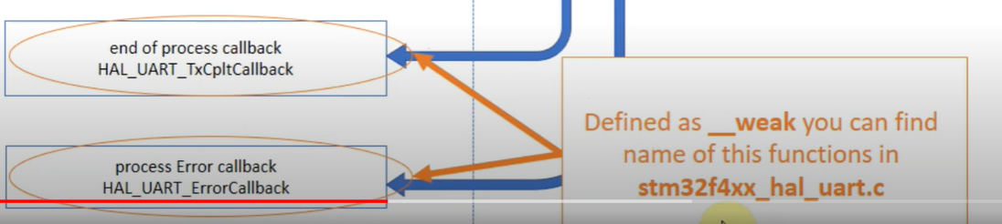

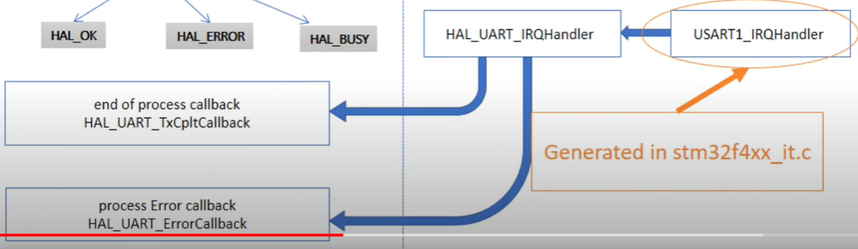

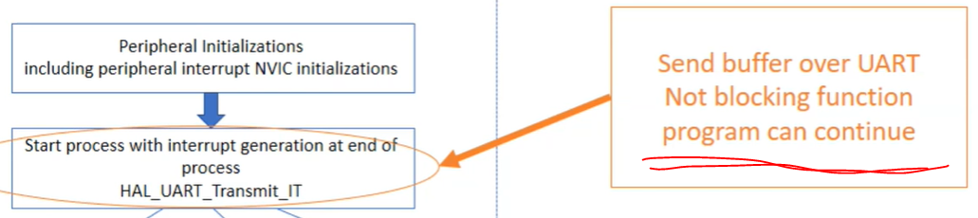

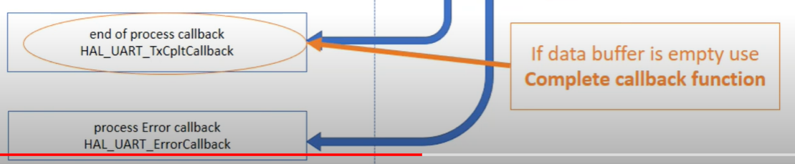

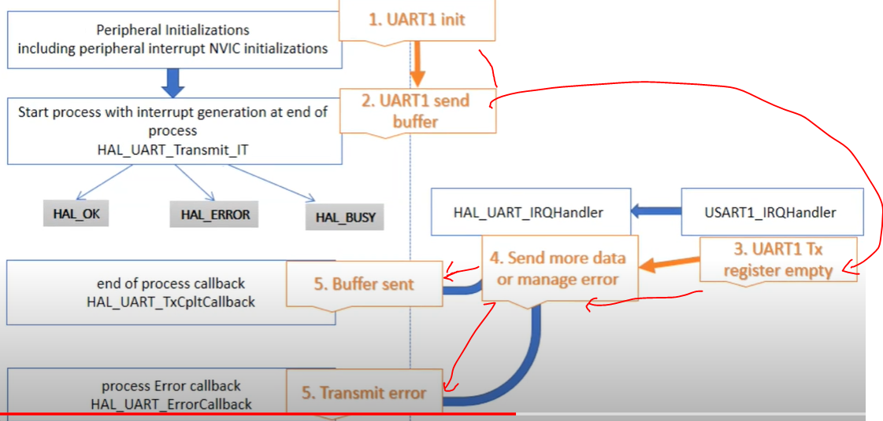

**Update: The major issue that the zprint() is rushing to send 1 ASCII a time to HAL_UART_Transmit_IT() that is not ready to transmit next byte!!, it need wait period before sending next one. For now HAL_UART_Transmit() with timeout is working solution. We can try upgrade the way zprint() send message, ie use TX buffer which once filled until ‘\n’ is emitted, then push into HAL_UART_Transmit_IT() or HAL_UART_Transmit_DMA().**

**We can try DMA approach and see if this work better for 1 ASCII a time.**

### DMA

1. Worked fine for fixed length frame
2. According to research, not possible to detect ‘\n’ by Peripheral to generate interrupts
3. Unable to use it for variable length message reception.

<https://www.eevblog.com/forum/microcontrollers/_best_-way-to-load-uart-data-to-ring-buffer-with-stm32hal/>

### Reading UART data: HAL

It very easy:

1. HAL_UART_Receive (&huart2, Rx_data, 4, 100); Polling
2. HAL_UART_Receive_IT(&huart2, Rx_data, 4); Interrupts
3. HAL_UART_Receive_DMA (&huart2, Rx_data, 4); DMA

Rx_Data = array buffer

4 = Number of data. In case it variable length, set to 1.

100 = timeout (blocking, crap)

### Received between IRQ or callback method

It's is called under UART IRQ for each byte received and the user callback **HAL_UART_RxCpltCallback()** is only executed at the end of the whole receive process, just after disabling the UART receive interrupt and receiving the last data.

### One Solution for DMA Message (unknown length) depends on timeout which indicates end of message

<http://stm32f4-discovery.net/2017/07/stm32-tutorial-efficiently-receive-uart-data-using-dma/>

In STM32 microcontroller family, U(S)ART reception can work in different modes:

* **Polling mode** (no DMA, no IRQ): Application must poll for status bits to check if new character has been received and read it fast enough in order to get all bytes
  + PROS
    - Very easy implementation, but no-one is using it in real-life scenario
  + CONS
    - Very easy to miss received characters in bursts of data
    - Works only for low baudrates
    - Application must very fast check for new character
* **Interrupt mode** (no DMA): UART triggers interrupt and CPU jumps to service routine to handle data reception
  + PROS
    - Most commonly used approach across all applications today
    - Works well in common baudrate, 115200 bauds
  + CONS
    - Interrupt service routine gets executed for every received character
    - May stall other tasks in high-performance MCUs with many interrupts
    - May stall operating system when receiving burst of data at a time
* **DMA mode:** DMA is used to transfer data from USART RX data register to user memory on hardware level. No application interaction is needed at this point except processing received data by application once necessary
  + PROS
    - Transfer from USART peripheral to memory is done on hardware level without CPU interaction
    - Can work very easily with operating systems
    - Optimized for highest baudrates > 1Mbps and low-power applications
    - In case of big bursts of data, increasing data buffer size can improve functionality
  + CONS
    - Number of bytes to transfer must be known in advance by DMA hardware
    - If communication fails, DMA may not notify application about all bytes transferred

This article focuses only on *DMA mode* with unknown data length to receive.

### UART Supporting Code: STM32L4 HAL Driver Folder (stm32l4xx_hal_uart)

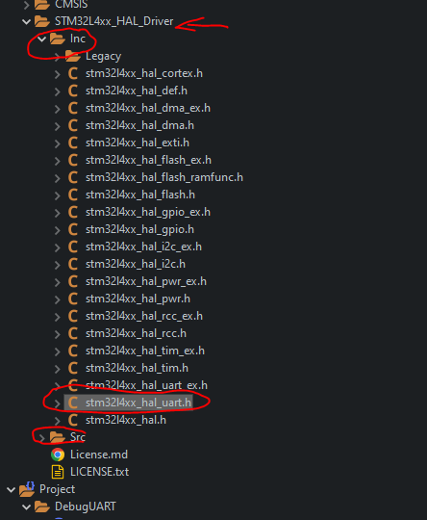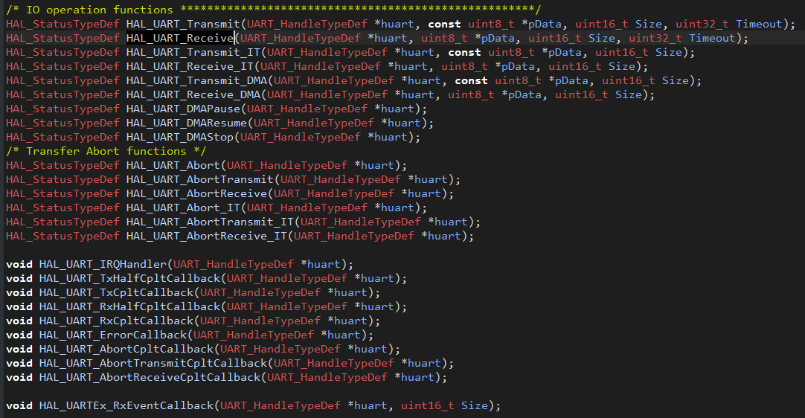

### HAL Documentation

===============================================================================

##### How to use this driver #####

===============================================================================

[..]

The UART HAL driver can be used as follows:

(#) Declare a UART_HandleTypeDef handle structure (eg. UART_HandleTypeDef huart).

(#) Initialize the UART low level resources by implementing the HAL_UART_MspInit() API:

(++) Enable the USARTx interface clock.

(++) UART pins configuration:

(+++) Enable the clock for the UART GPIOs.

(+++) Configure these UART pins as alternate function pull-up.

(++) NVIC configuration if you need to use interrupt process (HAL_UART_Transmit_IT()

and HAL_UART_Receive_IT() APIs):

(+++) Configure the USARTx interrupt priority.

(+++) Enable the NVIC USART IRQ handle.

(++) UART interrupts handling:

-@@- The specific UART interrupts (Transmission complete interrupt,

RXNE interrupt, RX/TX FIFOs related interrupts and Error Interrupts)

are managed using the macros __HAL_UART_ENABLE_IT() and __HAL_UART_DISABLE_IT()

inside the transmit and receive processes.

(++) DMA Configuration if you need to use DMA process (HAL_UART_Transmit_DMA()

and HAL_UART_Receive_DMA() APIs):

(+++) Declare a DMA handle structure for the Tx/Rx channel.

(+++) Enable the DMAx interface clock.

(+++) Configure the declared DMA handle structure with the required Tx/Rx parameters.

(+++) Configure the DMA Tx/Rx channel.

(+++) Associate the initialized DMA handle to the UART DMA Tx/Rx handle.

(+++) Configure the priority and enable the NVIC for the transfer complete

interrupt on the DMA Tx/Rx channel.

(#) Program the Baud Rate, Word Length, Stop Bit, Parity, Prescaler value , Hardware

flow control and Mode (Receiver/Transmitter) in the huart handle Init structure.

(#) If required, program UART advanced features (TX/RX pins swap, auto Baud rate detection,...)

in the huart handle AdvancedInit structure.

(#) For the UART asynchronous mode, initialize the UART registers by calling

the HAL_UART_Init() API.

(#) For the UART Half duplex mode, initialize the UART registers by calling

the HAL_HalfDuplex_Init() API.

(#) For the UART LIN (Local Interconnection Network) mode, initialize the UART registers

by calling the HAL_LIN_Init() API.

(#) For the UART Multiprocessor mode, initialize the UART registers

by calling the HAL_MultiProcessor_Init() API.

(#) For the UART RS485 Driver Enabled mode, initialize the UART registers

by calling the HAL_RS485Ex_Init() API.

[..]

(@) These API's (HAL_UART_Init(), HAL_HalfDuplex_Init(), HAL_LIN_Init(), HAL_MultiProcessor_Init(),

also configure the low level Hardware GPIO, CLOCK, CORTEX...etc) by

calling the customized HAL_UART_MspInit() API.

##### Callback registration #####

==================================

[..]

The compilation define USE_HAL_UART_REGISTER_CALLBACKS when set to 1

allows the user to configure dynamically the driver callbacks.

[..]

Use Function HAL_UART_RegisterCallback() to register a user callback.

Function HAL_UART_RegisterCallback() allows to register following callbacks:

(+) TxHalfCpltCallback : Tx Half Complete Callback.

(+) TxCpltCallback : Tx Complete Callback.

(+) RxHalfCpltCallback : Rx Half Complete Callback.

(+) RxCpltCallback : Rx Complete Callback.

(+) ErrorCallback : Error Callback.

(+) AbortCpltCallback : Abort Complete Callback.

(+) AbortTransmitCpltCallback : Abort Transmit Complete Callback.

(+) AbortReceiveCpltCallback : Abort Receive Complete Callback.

(+) WakeupCallback : Wakeup Callback.

#if defined(USART_CR1_FIFOEN)

(+) RxFifoFullCallback : Rx Fifo Full Callback.

(+) TxFifoEmptyCallback : Tx Fifo Empty Callback.

#endif

(+) MspInitCallback : UART MspInit.

(+) MspDeInitCallback : UART MspDeInit.

This function takes as parameters the HAL peripheral handle, the Callback ID

and a pointer to the user callback function.

[..]

Use function HAL_UART_UnRegisterCallback() to reset a callback to the default

weak (surcharged) function.

HAL_UART_UnRegisterCallback() takes as parameters the HAL peripheral handle,

and the Callback ID.

This function allows to reset following callbacks:

(+) TxHalfCpltCallback : Tx Half Complete Callback.

(+) TxCpltCallback : Tx Complete Callback.

(+) RxHalfCpltCallback : Rx Half Complete Callback.

(+) RxCpltCallback : Rx Complete Callback.

(+) ErrorCallback : Error Callback.

(+) AbortCpltCallback : Abort Complete Callback.

(+) AbortTransmitCpltCallback : Abort Transmit Complete Callback.

(+) AbortReceiveCpltCallback : Abort Receive Complete Callback.

(+) WakeupCallback : Wakeup Callback.

#if defined(USART_CR1_FIFOEN)

(+) RxFifoFullCallback : Rx Fifo Full Callback.

(+) TxFifoEmptyCallback : Tx Fifo Empty Callback.

#endif

(+) MspInitCallback : UART MspInit.

(+) MspDeInitCallback : UART MspDeInit.

[..]

For specific callback RxEventCallback, use dedicated registration/reset functions:

respectively HAL_UART_RegisterRxEventCallback() , HAL_UART_UnRegisterRxEventCallback().

[..]

By default, after the HAL_UART_Init() and when the state is HAL_UART_STATE_RESET

all callbacks are set to the corresponding weak (surcharged) functions:

examples HAL_UART_TxCpltCallback(), HAL_UART_RxHalfCpltCallback().

Exception done for MspInit and MspDeInit functions that are respectively

reset to the legacy weak (surcharged) functions in the HAL_UART_Init()

and HAL_UART_DeInit() only when these callbacks are null (not registered beforehand).

If not, MspInit or MspDeInit are not null, the HAL_UART_Init() and HAL_UART_DeInit()

keep and use the user MspInit/MspDeInit callbacks (registered beforehand).

[..]

Callbacks can be registered/unregistered in HAL_UART_STATE_READY state only.

Exception done MspInit/MspDeInit that can be registered/unregistered

in HAL_UART_STATE_READY or HAL_UART_STATE_RESET state, thus registered (user)

MspInit/DeInit callbacks can be used during the Init/DeInit.

In that case first register the MspInit/MspDeInit user callbacks

using HAL_UART_RegisterCallback() before calling HAL_UART_DeInit()

or HAL_UART_Init() function.

[..]

When The compilation define USE_HAL_UART_REGISTER_CALLBACKS is set to 0 or

not defined, the callback registration feature is not available

and weak (surcharged) callbacks are used.

@endverbatim

******************************************************************************

*/

### USART2: High Level Spec & Planning

The Spec is based on following

1. UDTERM command protocol
2. Variable length up to 300 byte, this sufficient to transfer 256 byte from the FLASH pages
3. End of line detection as end of the frame = ‘\n’, copied into buffer
4. ASCII based command, but can be binary mode for high bulk transfer.
5. Filter out ‘\0’ null (if occurred).
6. Fixed 115200 Baud, 1 stop bit, etc.
7. Double buffer approach.

The USUART implementation planning, based on research

1. Cube MX to setup initial code
2. Cannot use DMA since it lacks ASCII detection.
   1. More research is needed.
3. Cannot use polling.
4. This leave interrupts solution.

### USUART2: Code Works

* Use IDECodeMX to configure the UART for you, it easier this way
* Below is how they generate the basic UART function (No DMA, No callback, etc)

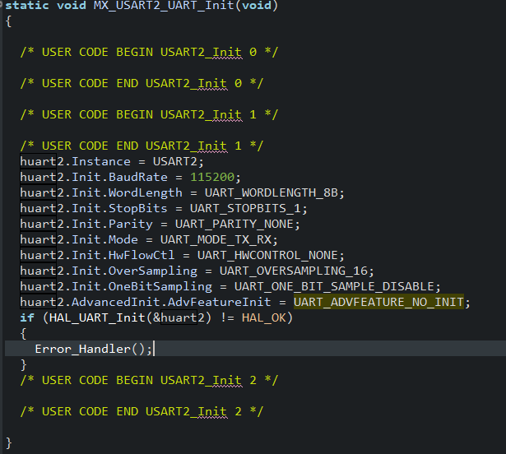

After the HX configuration, the below code must be run as per STM32 USART rules.

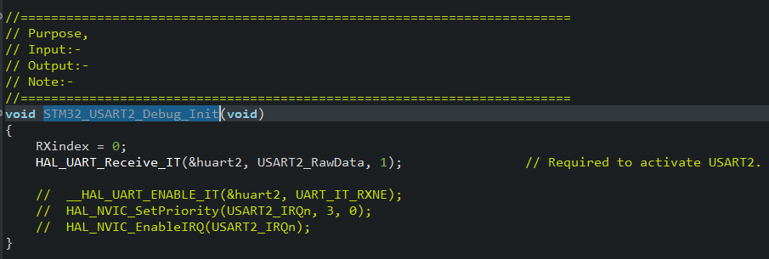

The USART2_RawData is kept short since it only receives 1 byte at a time. I leave it to 3 array.

Then when it received the RX comm until end of line, then it goes to UDT command process as shown below.

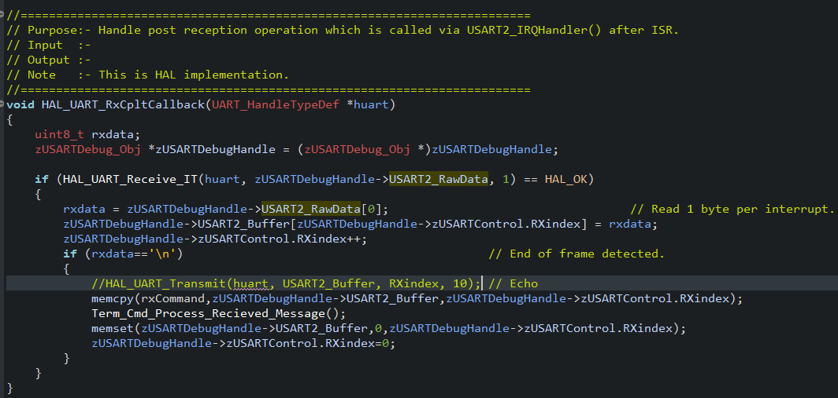

This is correct implementation. No need to modify the IRQ code. The STM32 code run the HAL_UART_RxCpltCallback(…) code to above.

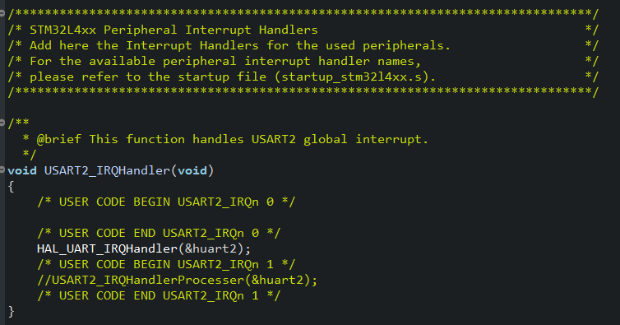

Just to note the HAL_UART_IRQHandler() seem to run quite a bit of code (excessive code in fact) which can be stripped down to minimum in later revision so it spend less time checking flag for error, etc.

### USART: Fractional Baud Setting: This is good.

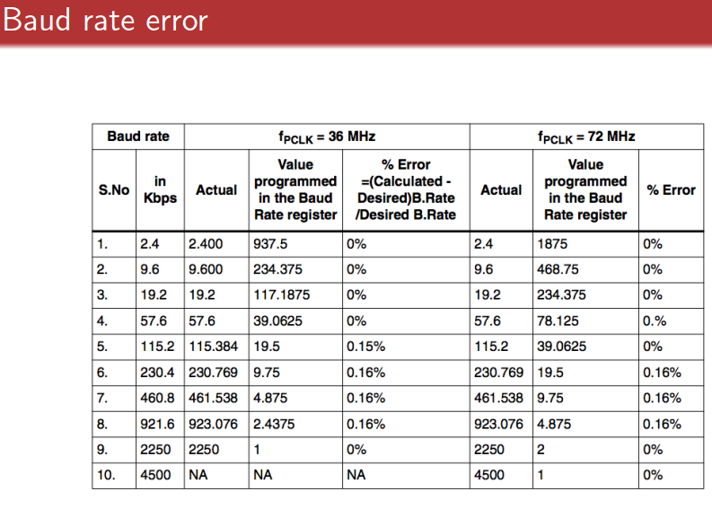

### USART Overview

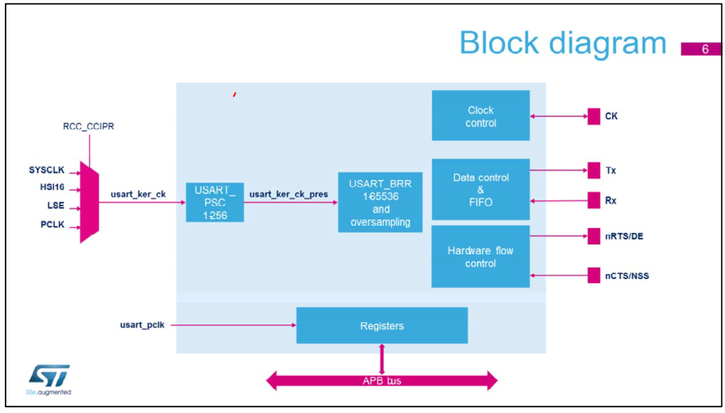

* Below shown dual clock structure
* The USART has a flexible clocking scheme. The registers are accessed through the APB bus, and the kernel is clocked with usart_ker_ck (prescaled or not) which is independent from the APB clock.

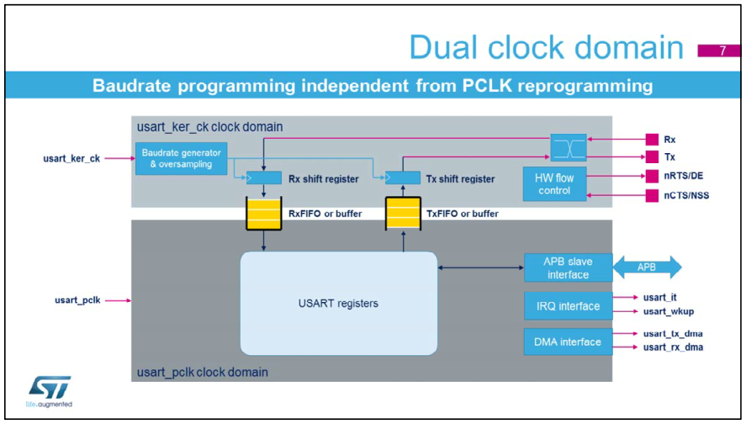

### Printf() note

<https://community.st.com/s/question/0D53W000004HHzVSAW/printf-usage-in-stm32>

The library printf may not be thread safe, and may use excessive CPU time spin waiting on the communications channel, possibly even with interrupts disabled.

I personally NEVER use printf in embedded code. I have my own serial output routines that I can send message through to track the program, that I know have been made thread safe, and have know blocking characteristics.

Some interesting discussion

<https://electronics.stackexchange.com/questions/105283/why-is-printf-bad-for-debugging-embedded-systems>

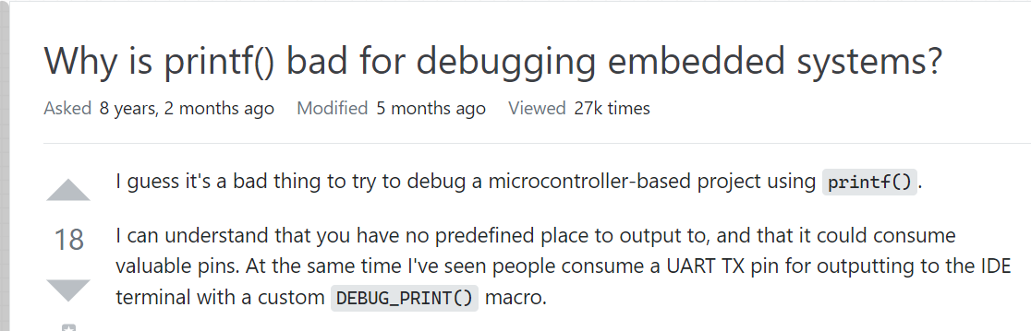

### USART Transmits (Interrupt)

<https://controllerstech.com/uart-transmit-in-stm32/>

HAL_UART_Transmit_IT(&huart2, data, sizeof (data));

There DMA method but not sure how to mix and match between RX Interrupt and TX DMA.I think the DMA is better solution than interrupt but other time

# STM32L476: ADC12

## Overview

* Interleave two ADC!2 allow up to 10MSPS sample rate (per channel?)
* 3V0 VREF
* Run on 80MHz Bus and ADC12 peripheral clock.
* 12.5 clock for 12 bits.

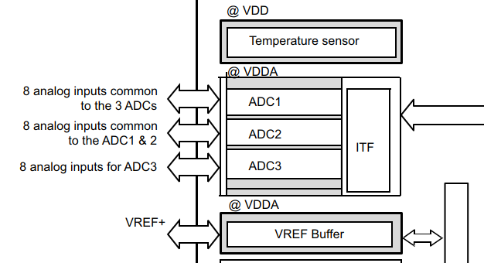

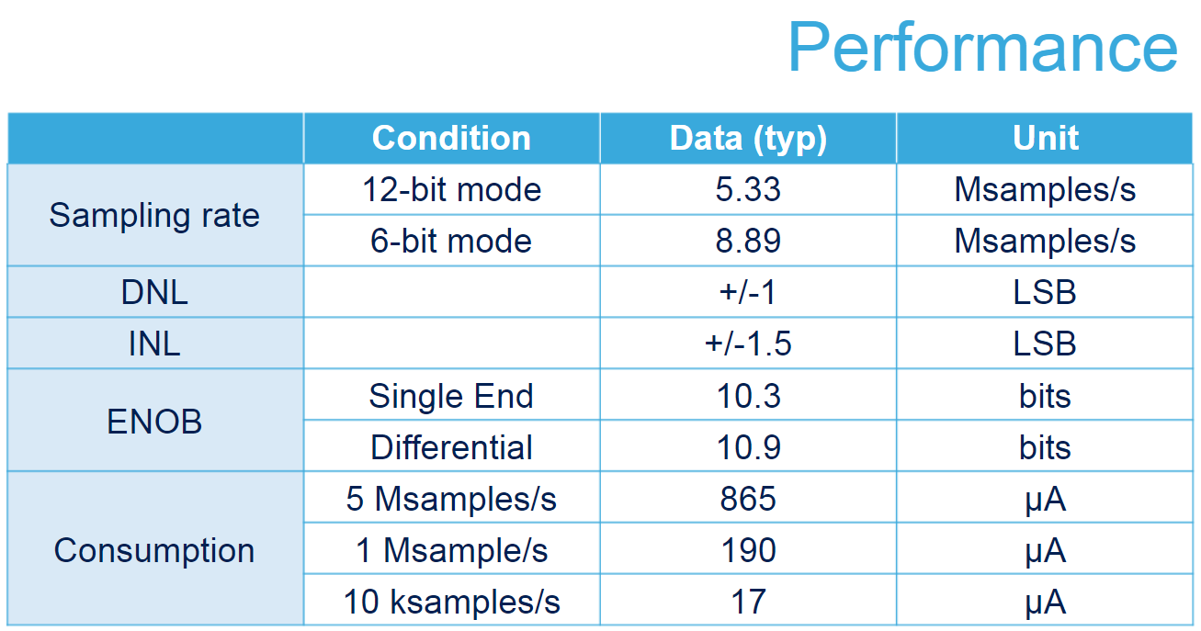

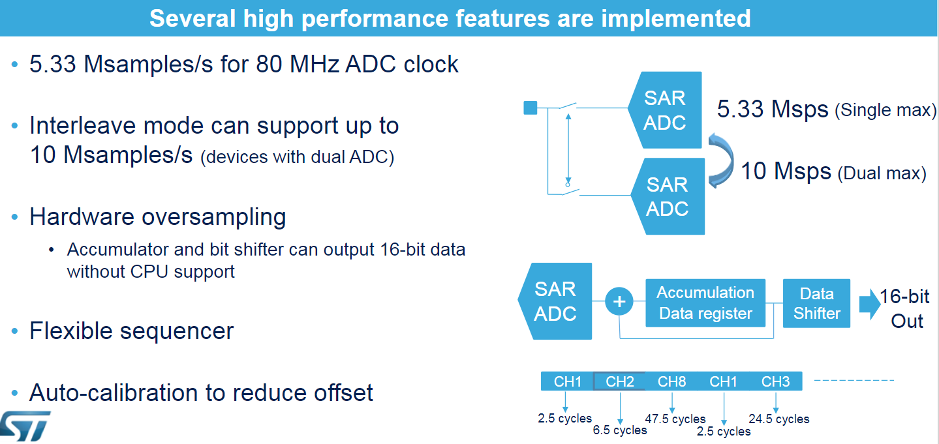

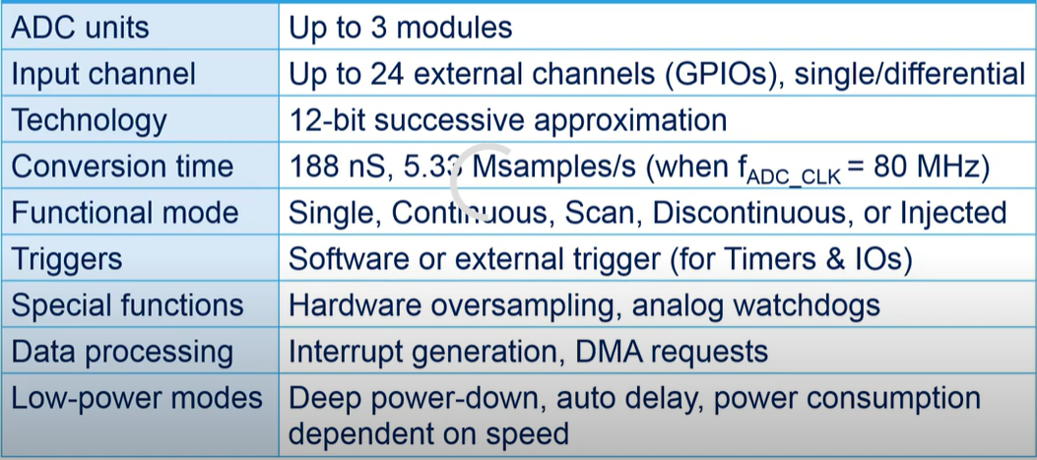

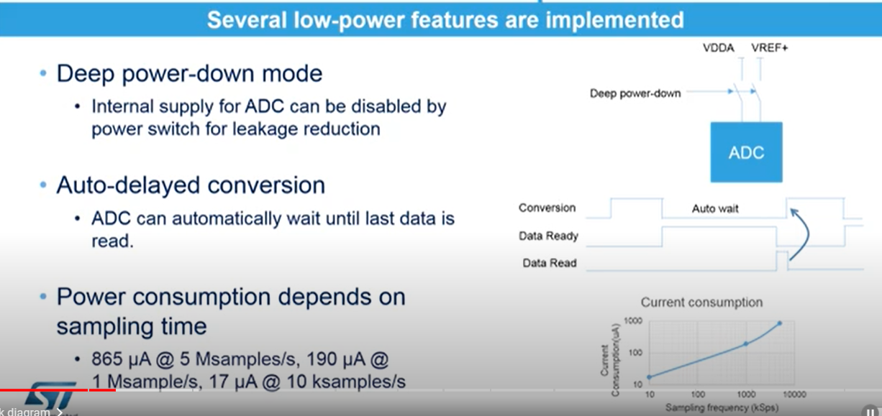

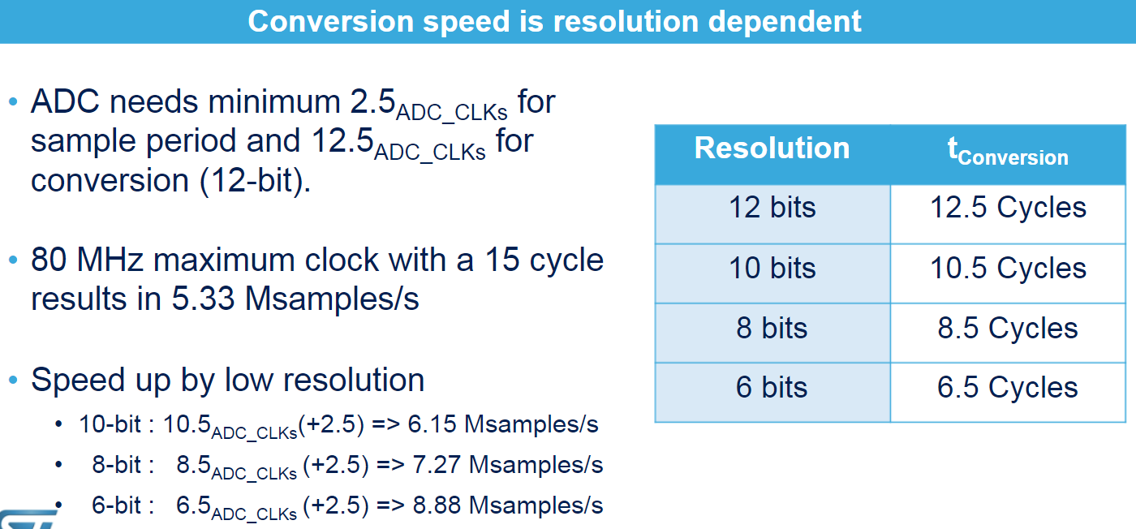

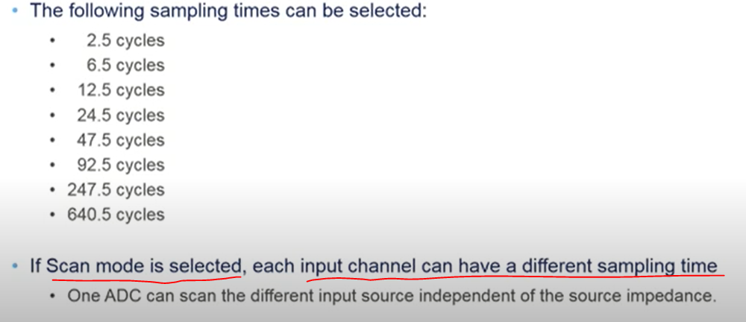

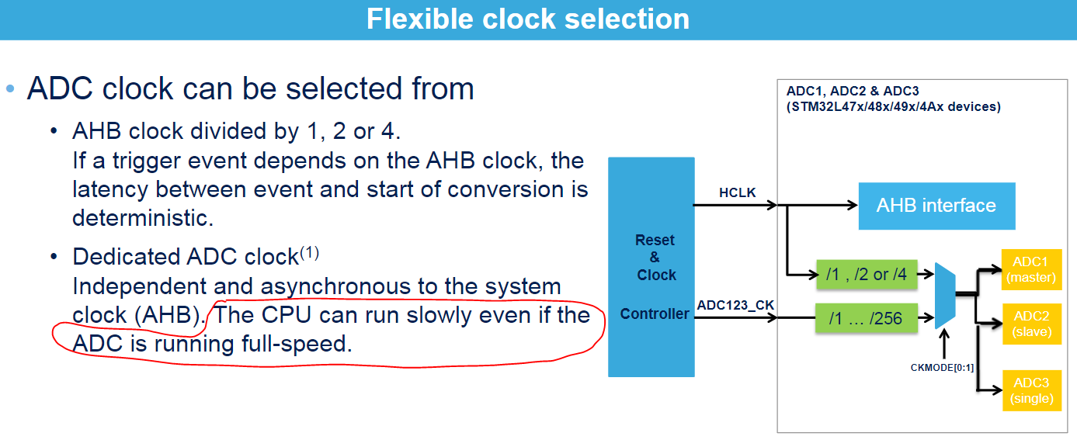

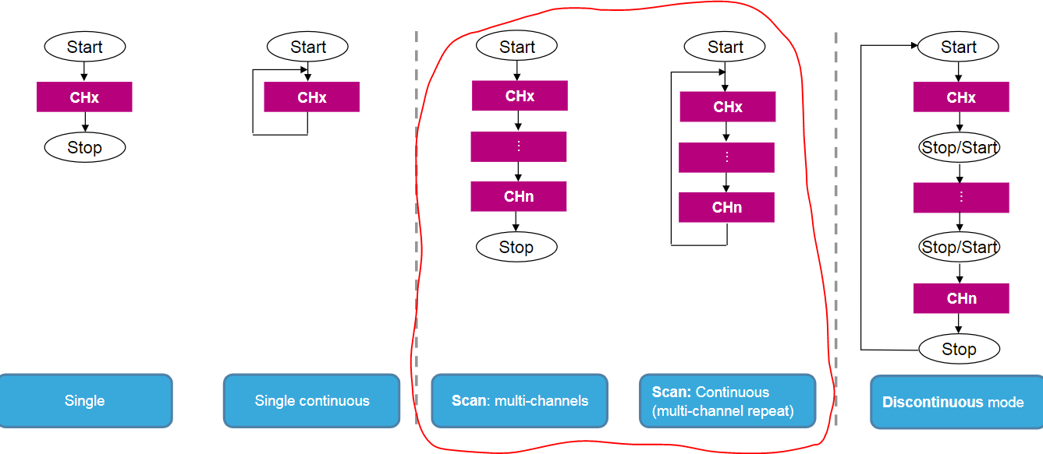

* We can leave ADC12 running in multi-channel continuous loop to DMA and only capture value, when DMA is active.
* We can set to 1KHz sample rate for 8 channel to begin this project on ADC1 only. Leave ADC2 and ADC3 other time, keep it simple.
* Suggest to run x16 over sampling for 14 bits resolution, but not accuracy.

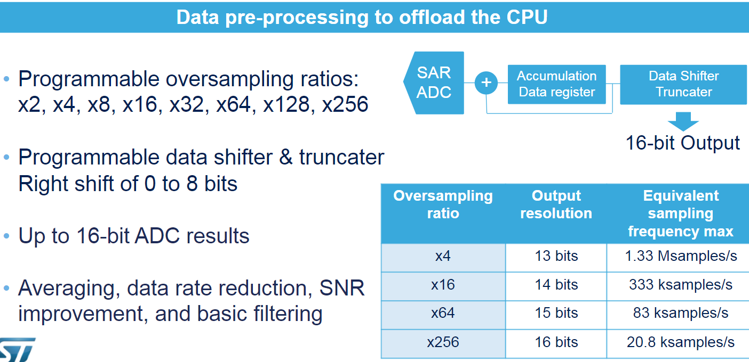

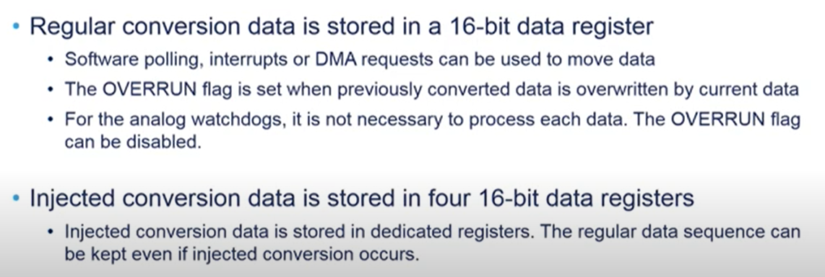

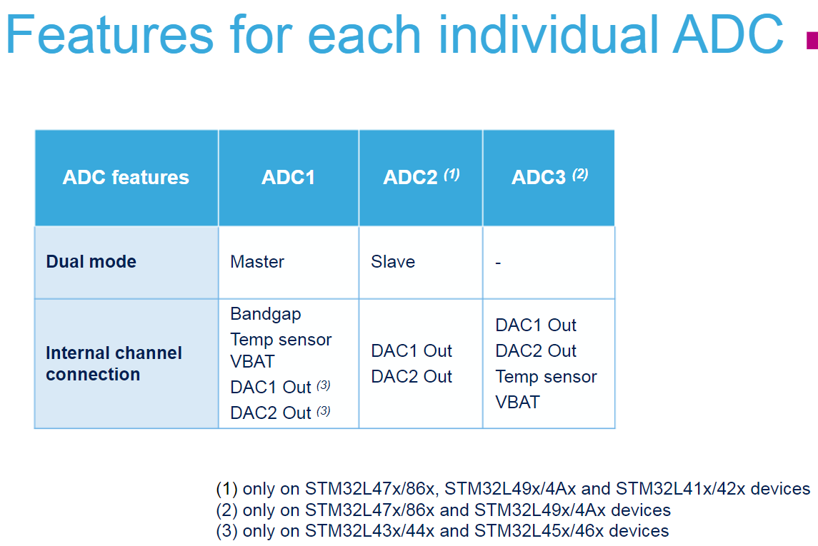

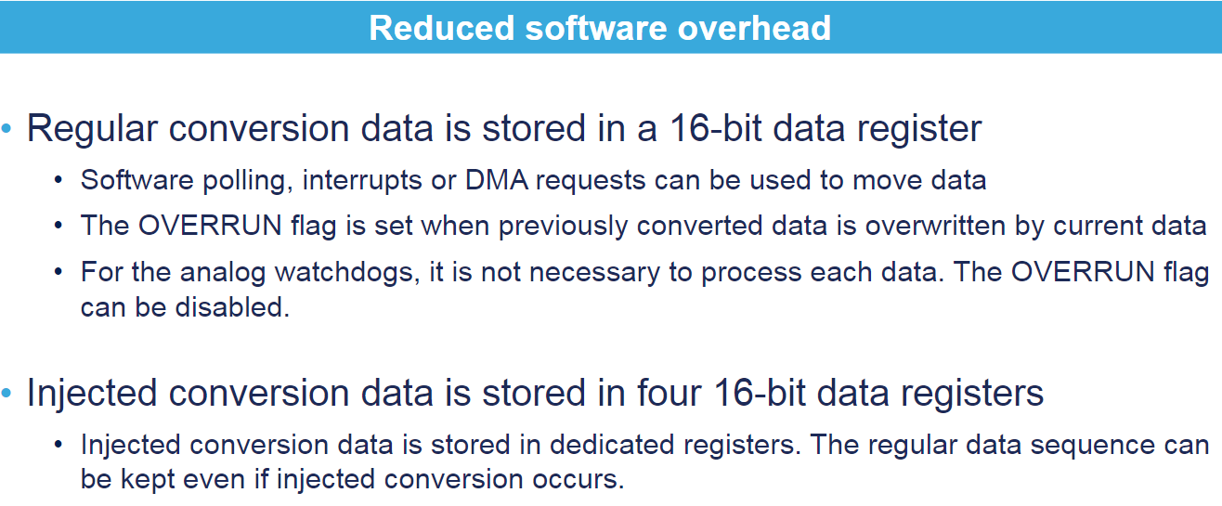

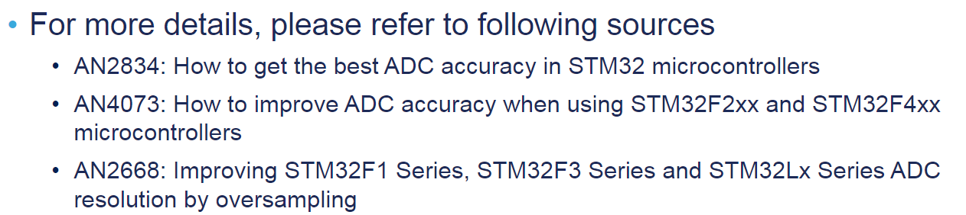

### DMA Interrupts

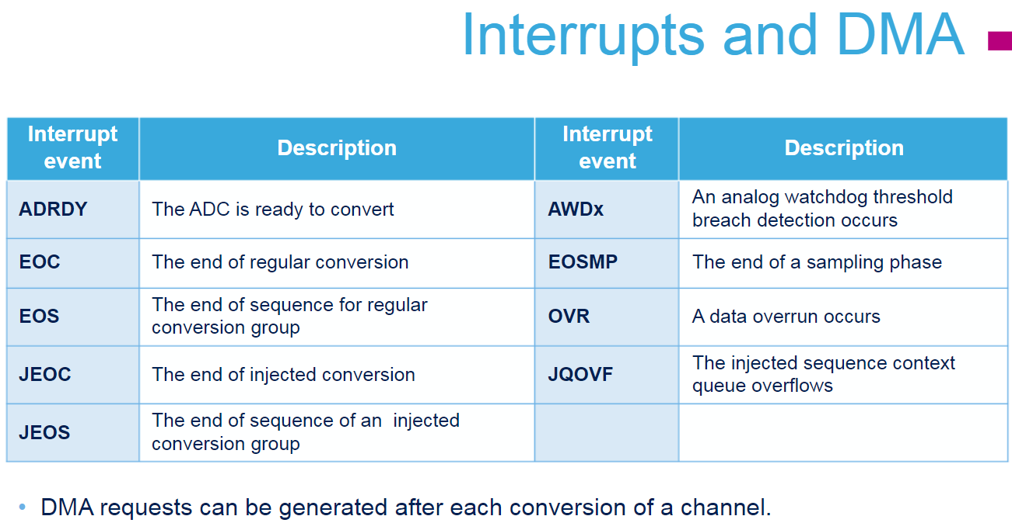

## Initial MX Works

### Channel Assignment

* Limited to PA0, PA4,PA1, PB0,PC1, PC0 available for ADC12 service.

GPIO ADC12 Channel Seq CH (DMA)/Rank

* + 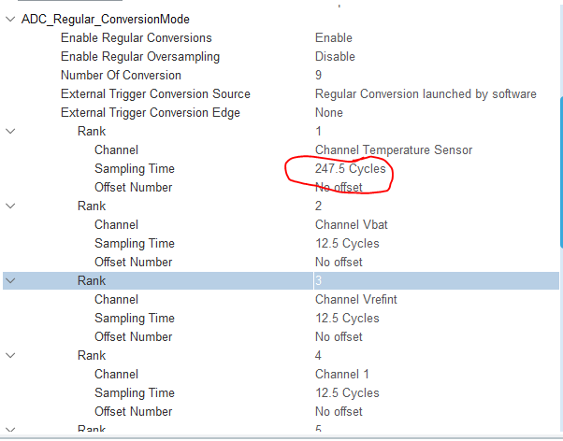TEMP ?? 1
  + VBAT ?? 2
  + VREFINT IN0 3
  + PC1, IN1 4
  + PC0 IN2 5
  + PB0, IN15 9

----------------------------

* + ~~PA0, IN5 6~~
  + ~~PA1, IN6 7~~
  + ~~PA4, IN9 8~~
* Above sorted by ranks.
* ADC12NOOFCHANNELS = 9 for 9 channel above (array index = 0 to 8)
* Sync with MX setup

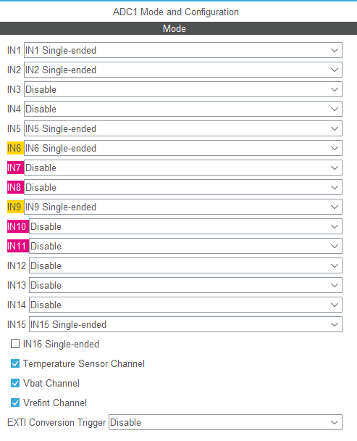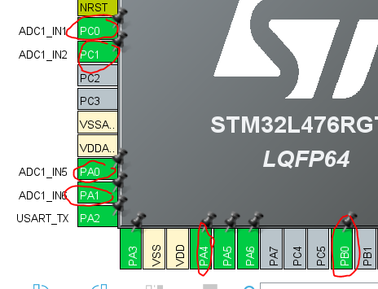

###TASK: In Temo channel, need to check requirements for 247.5 Cycle sample time as this number applied to F0 series not L4 series, check later.

### Clock to ADC12: 16MHz

* Above is the clock section from the CubeMx. Note that I have selected the ADC clock as 14 MHz.
* **The reason behind this** is that the Temp sensor sampling time needs to be 17.1 us.
* While in the ADC setting, we have maximum sampling time as 239.5 cycles. So (239.5/14) gives us 17.1 us sampling time

Thus: Maximum sample time is 239.5 Cycle / 16MHz = 15uSec which is okay since max is not specified in L4 datasheet.

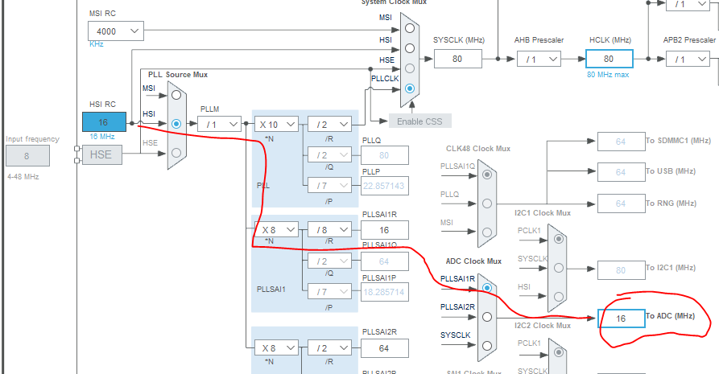

### DMA Setup

* Make sure to set Data-Width to Word not half-word!!!!
* This is what causing the problem!!!!

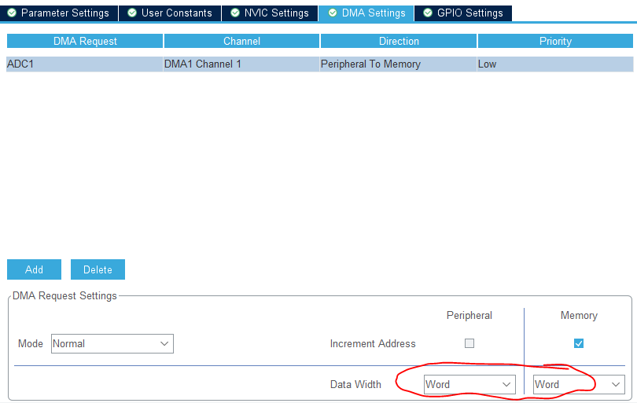

### Issue with DMA and HAL

<https://community.st.com/s/question/0D50X0000BqCJ96SQG/stm32l4-adcdma-how-to-get-an-interrupt-when-the-buffer-is-filled>

*Sorry, you misunderstood my comment.* ***You need to get rid of all the hal crap and write your own ​low level isr****. Look in startup_32xxxxx.s and find the name in the interrupt vector table that matches the dma and stream you are using.*

*In my code, i am using dma with adc multimode on an f730, so i use dma2_stream0 for adc1 ( table in dma description of RM ) and declare*

*​*

*void DMA2_Stream0_IRQHandler( void )*

*​*

*Function in main.c*

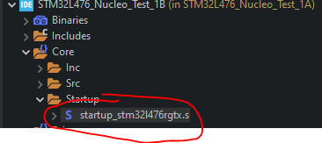*​*

*In the isr you need to read LISR to find the cause of the interrupt ( either buffer half or full​ ) and then clear the bit by writing to LIFCR.*

*Again, the compiler or linker will complain about multiple definition of the isr, just delete/comment out the old one.*

*Also, write your own initialization code. It's the only way to know that it's done properly. Setting up a dma with double buffering and interrupt is only like 8 lines of simple code.​ study the RM and use the debugger, it will start to make sense.*

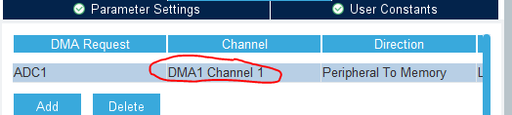 It on channel 1 DMA

Check in .s filename and found this weak function.

DMA1_Channel1_IRQHandler

**void** DMA1_Channel1_IRQHandler(**void**)

{

/* USER CODE BEGIN DMA1_Channel1_IRQn 0 */

/* USER CODE END DMA1_Channel1_IRQn 0 */

HAL_DMA_IRQHandler(&hdma_adc1);

/* USER CODE BEGIN DMA1_Channel1_IRQn 1 */

/* USER CODE END DMA1_Channel1_IRQn 1 */

}

Below callback function indicate complete transfer

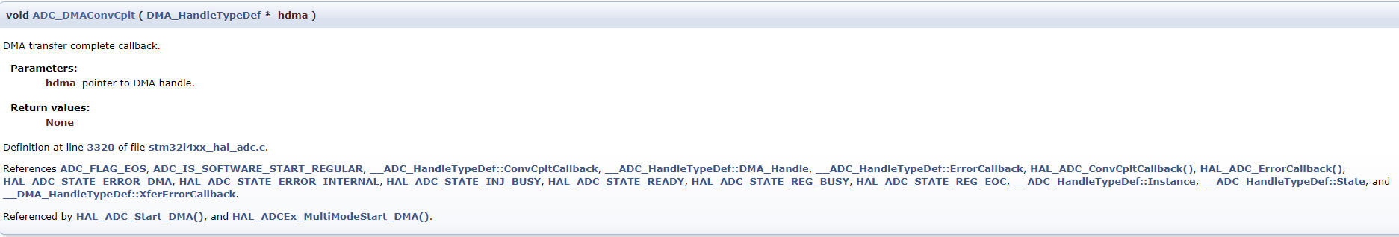

### ADC HAL function

<http://www.disca.upv.es/aperles/arm_cortex_m3/llibre/st/STM32L486xx_User_Manual/group__adc__exported__functions__group2.html>

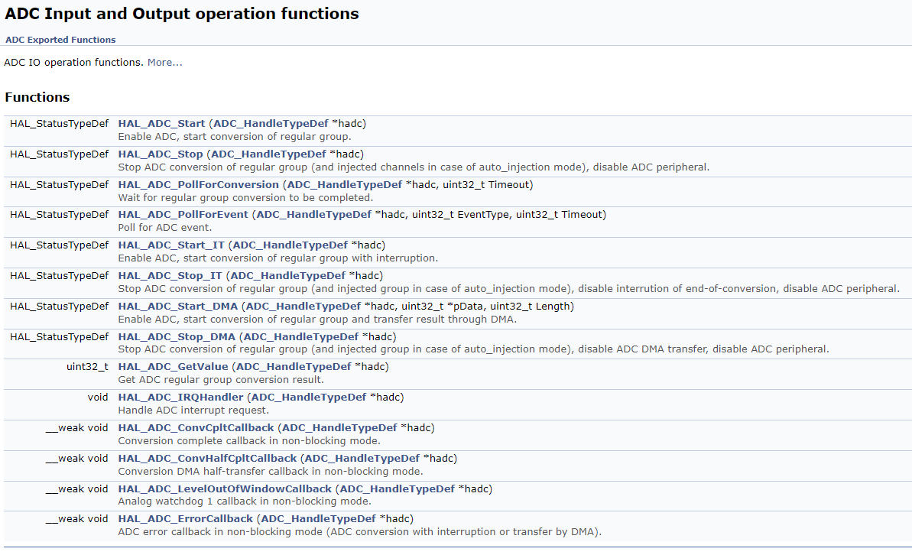

### Observation Note about temp measurement

1. Based on 64 pin packages, the VREF+ (for ADC12) is tied to VDDA which is 3V3.
   1. SB57 is linked
   2. So ADC12 work between 3V3 to GND.
   3. It not tied to 3V0VREF.
2. The calibration of temp is tied to the 3V0 not 3V3.
3. Some form of correction is required.
4. Datasheet and Note from STM32 is poorly written and confusing.
   1. There useful document: E:\014_WorkSTM32\020_VREF_TEMP_Document\STM32_VREF.pdf
   2. The main issue with VREF generally is, that there are many "references" involved in related texts, and there's not a single unified nomenclature for them. ST often uses confusing nomenclature and their formulae are sometimes written from an impractical point of view, increasing the confusion.
5. So let's just derive ours.
   1. Let's denote this VREF+/VDDA reference voltage vrefext.
   2. MAX = 12 bit = 4096
   3. Meas = Capture readout (ADC12)
   4. vmeas = vrefext * MEAS / MAX = 3.3V * Meas /4096

### VBAT: VBAT(ADC12) = 1/3 * VBAT Pin

* PIN 1 = VBAT, thus 3.317V / 3

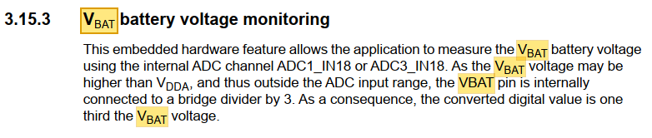

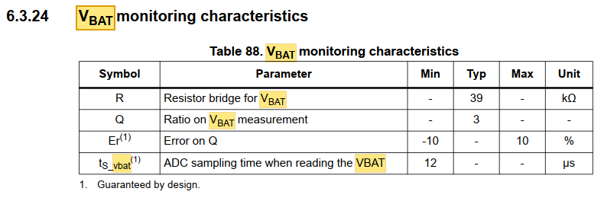

### Tutorial: Internal Temp Sensor: L4 Datasheet review

* The temperature sensor (TS) generates a voltage VTS that varies linearly with temperature.
* The temperature sensor is internally connected to the ADC1_IN17 and ADC3_IN17 input channels which is used to convert the sensor output voltage into a digital value.
* The sensor provides good linearity but it has to be calibrated to obtain good overall accuracy of the temperature measurement. As the offset of the temperature sensor varies from chip to chip due to process variation
* Accurate to +/-5C
* 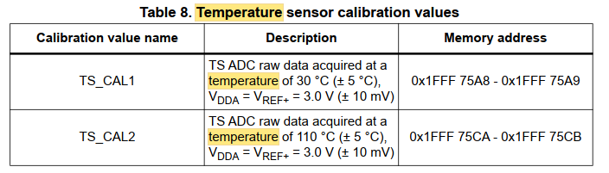

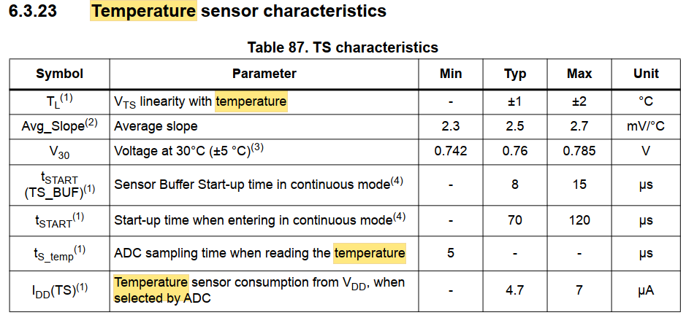

### Tutorial: Internal Voltage Ref

* VREFINT is internally connected to the ADC1_IN0

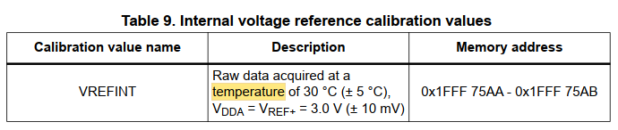

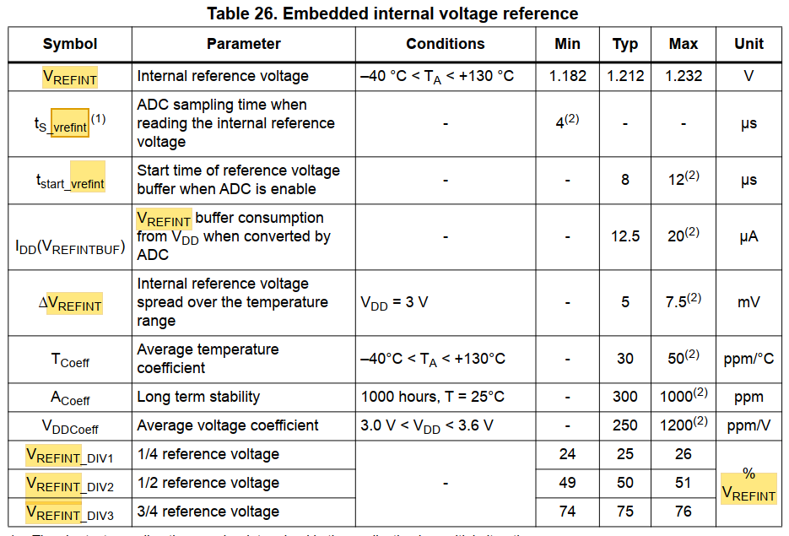

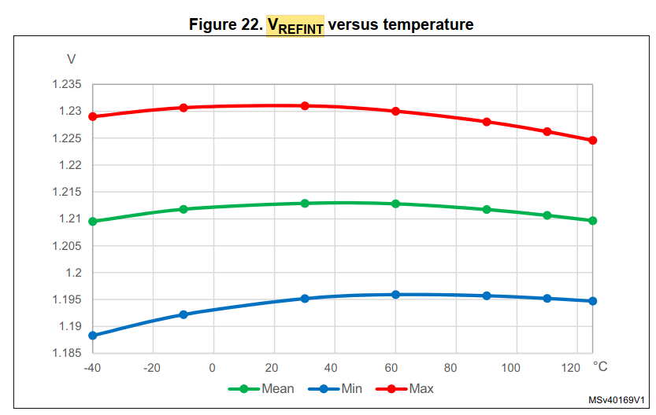

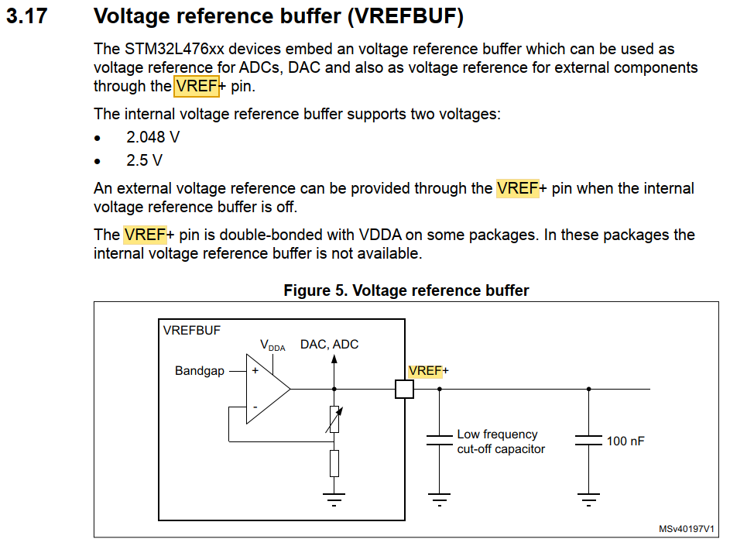

But the VREF- and VREF+ is shared with VSSA and VDDA thus it is 3V3 not 3V0.

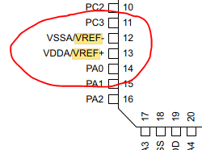 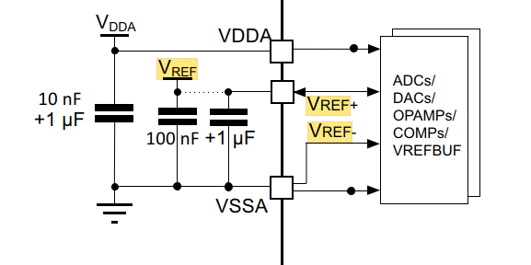

### Tutorial: STM32 ADC Multiple Channels with DMA

<https://controllerstech.com/stm32-adc-multiple-channels/>

* In order to read the multiple channels, we need to use DMA. The benefit of it is the conversion will take place in the background and we can perform some other operation with the controller and when we need the values, we can just read them easily.

## L4 Library Example Code

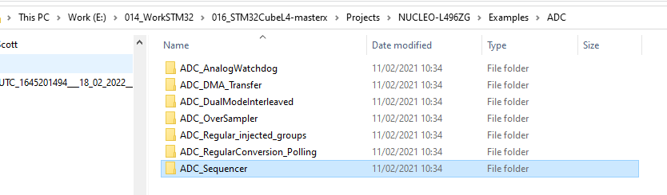

# How to implement LL Driver

## MX Method

Step 1: Activate SPI Bus, select Mode as needed

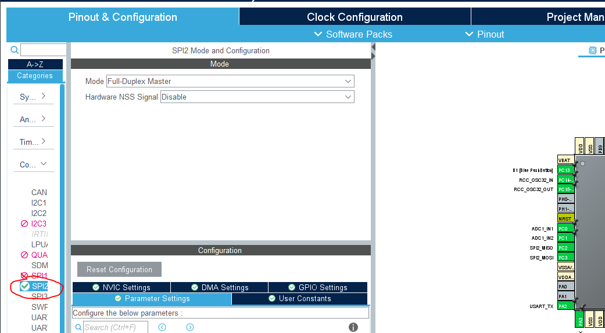

Step 2: In project manager

* Select SPI to LL
* And that it.

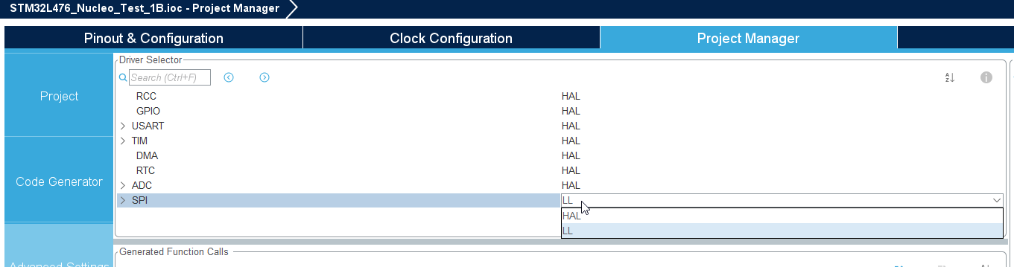

## What changed in code?

Preprocessor has new statement : USE_FULL_LL_DRIVER

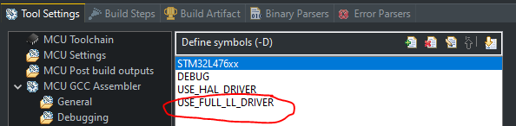

Then in main.h

**#ifndef** __MAIN_H

**#define** __MAIN_H

**#ifdef** __cplusplus

**extern** "C" {

**#endif**

/* Includes ------------------------------------------------------------------*/

**#include** "stm32l4xx_hal.h"

**#include** "stm32l4xx_ll_spi.h"

**#include** "stm32l4xx_ll_bus.h"

**#include** "stm32l4xx_ll_cortex.h"

**#include** "stm32l4xx_ll_rcc.h"

**#include** "stm32l4xx_ll_system.h"

**#include** "stm32l4xx_ll_utils.h"

**#include** "stm32l4xx_ll_pwr.h"

**#include** "stm32l4xx_ll_gpio.h"

**#include** "stm32l4xx_ll_dma.h"

**#include** "stm32l4xx_ll_exti.h"

## Remove the SPI LL and see if manually put back

Put SPI to disabled

Put <USE_FULL_LL_DRIVER> into the preprocessor

Then apply stm324xx_ll_spi.h

Result: it did not work!!!

## Cube Project File Structure

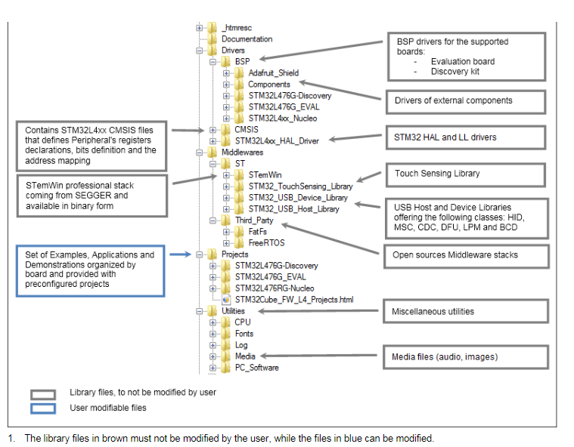

## LL includes via Dirty Trick!!!

1. This is working project folder without compete LL package.
   * E:\014_WorkSTM32\STM32F3\Test1A\STM32L476_Nucleo_Test_1A\Drivers\STM32L4xx_HAL_Driver\Inc

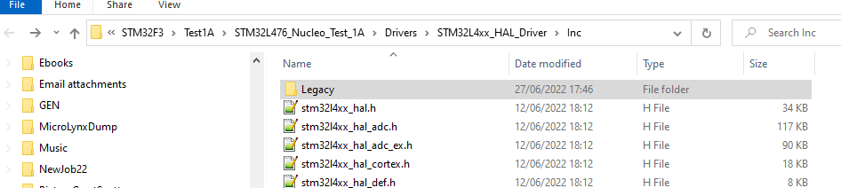

1. The complete collection of LL driver is found in the master STM32L4

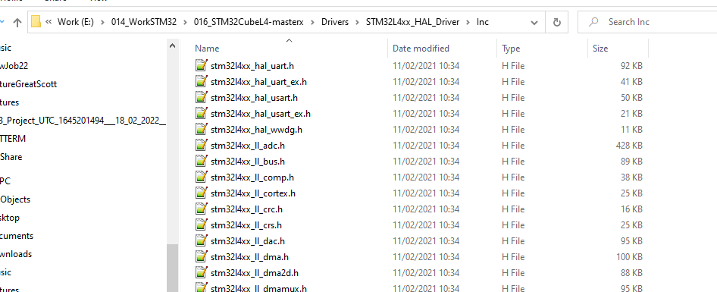

* E:\014_WorkSTM32\016_STM32CubeL4-masterx\Drivers\STM32L4xx_HAL_Driver\Inc
* There also .c file in src folder.

1. The dirty trick is to create new folder 000_LL_Driver and included them in project properties, in this way whatever MXCube change, will not remove it, however keep eye open for deletion of < USE_FULL_LL_DRIVER>. It complies without issue.

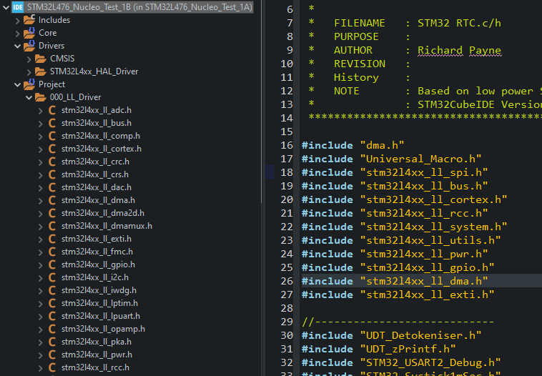

1. Text file added

Copied from

E:\014_WorkSTM32\016_STM32CubeL4-masterx\Drivers\STM32L4xx_HAL_Driver\Inc

to

E:\014_WorkSTM32\STM32F3\Test1A\STM32L476_Nucleo_Test_1A\Project\000_LL_Driver

In this way, MXCube will not remove the LL code during update (ioc).

However it may remove the USE_FULL_LL_DRIVER in preprocessor project setting, this may need to be put back.

STM32 file kit bsed on V1.17.0 / 11-February-2021

# STM32L469 MCU Discovery Kit

<https://www.st.com/en/evaluation-tools/32f469idiscovery.html>

<https://www.st.com/en/evaluation-tools/32f469idiscovery.html#st-also-like>

## Overview

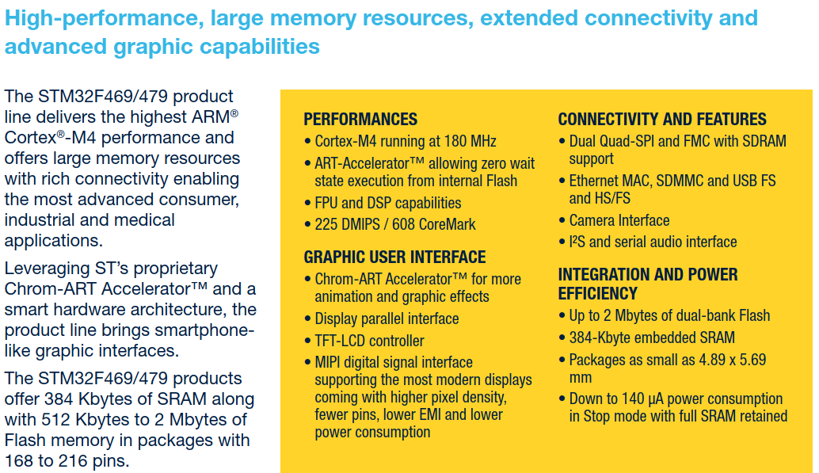

## STM32F469 MCU

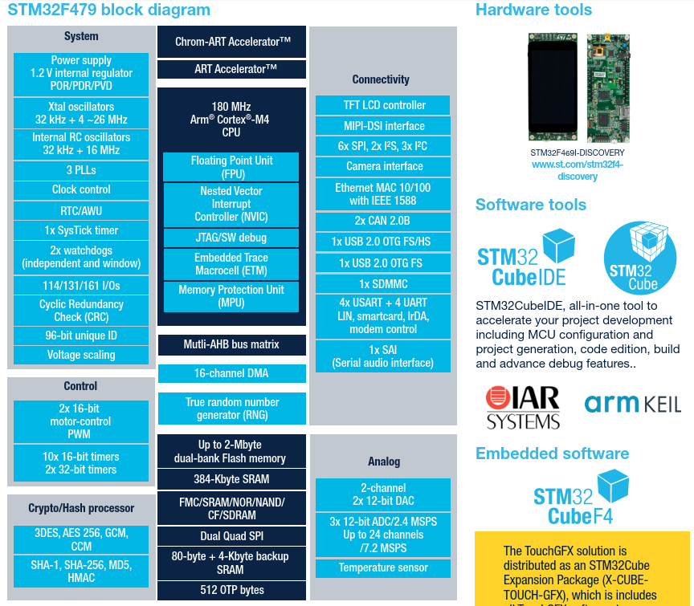

## Begin with bare project: STM32_DIS_TEST_1A

### Setup

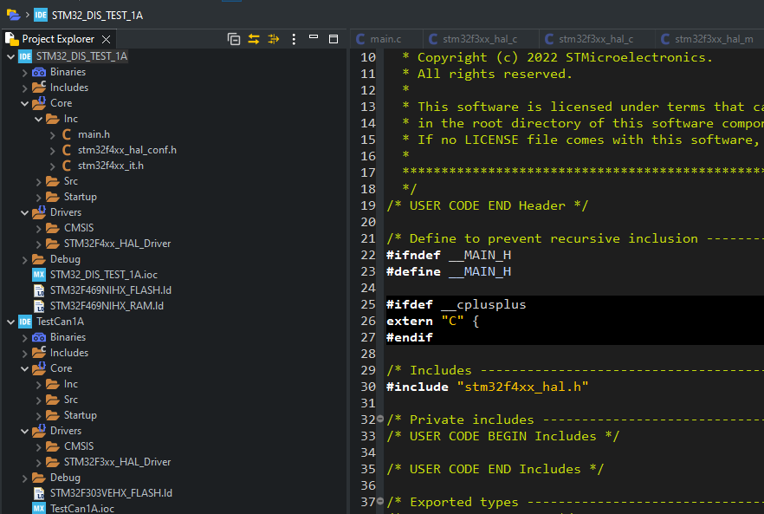

### Resource Setup

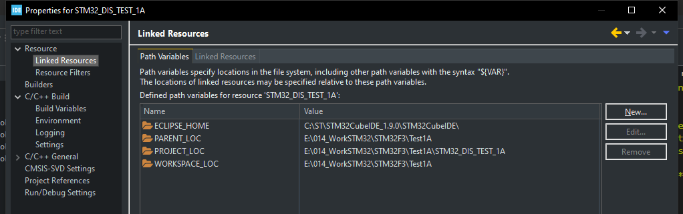

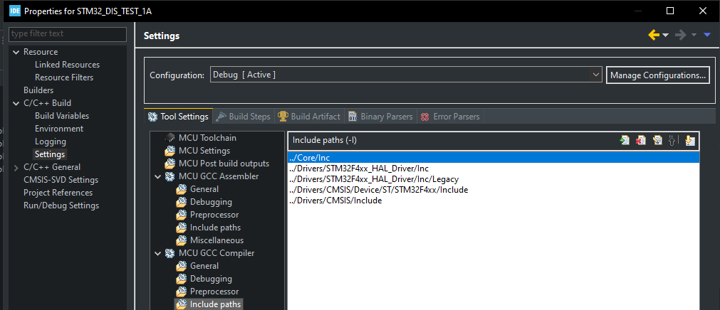

# STM32L4 Seminar (Sensor Expo 2019)

* STM32L4 Discovery Kit Iot Node
* <https://www.digikey.ca/en/product-highlight/s/stmicroelectronics/stm32l4-iot-discovery-kit-iot-node>

